|  |
| --- |
| Name: V P N Sulakshika |
| Student Reference Number: 10707385 |



|  |  |  |
| --- | --- | --- |
| Module Code: PUSL3111 | Module Name: API Software Development | |
| Coursework Title: Sri Lanka Bureau of Foreign Employment (SLBFE) - REST API Web and Mobile Applications | | |
| Deadline Date: Wednesday, 11 May 2022, 11:30 AM | | Member of staff responsible for coursework: Dr. Rasika Ranaweera |
| Programme: BSc (Hons) Software Engineering | | |
| Please note that University Academic Regulations are available under Rules and Regulations on the University website [www.plymouth.ac.uk/studenthandbook](http://www.plymouth.ac.uk/studenthandbook). | | |
| Group work: please list all names of all participants formally associated with this work and state whether the work was undertaken alone or as part of a team. Please note you may be required to identify individual responsibility for component parts.  **Group No - 21**  10707385 - V P N Sulakshika **(Group Leader)**  10707241 - H S Kaushalya  10707417 – H J K I Wijerama  10707129 – K L D Anupama  10707372 - P D S Sigera  10707291 – S S N S Nevins  ***We confirm that we have read and understood the Plymouth University regulations relating to Assessment Offences and that we are aware of the possible penalties for any breach of these regulations. We confirm that this is the independent work of the group.***  Signed on behalf of the group: | | |
| Individual assignment: ***I confirm that I have read and understood the Plymouth University regulations relating to Assessment Offences and that I am aware of the possible penalties for any breach of these regulations. I confirm that this is my own independent work.***  Signed : | | |
| Use of translation software: failure to declare that translation software or a similar writing aid has been used will be treated as an assessment offence.  I *have used/not used translation software.  If used, please state name of software………………………………………………………………… | | |
| **Overall mark _____% Assessors Initials ______ Date_________** | | |

*Please delete as appropriateSci/ps/d:/students/cwkfrontcover/2013/14

Table of Contents

Appendix 6

1. Introduction 7

2. API Documentation 7

2.1. List of APIs 7

2.2. Screenshots 9

2.2.1. Code Screenshots - Backend 9

2.2.1.2. Mobile Application 9

2.2.2. Run-Time Screenshots 9

3. Tools and Technologies 14

3.1. Platform - Web Platform 18

3.2. Platform – Mobile Platform 18

4. Individual Contribution 19

4.1. 10707385 - V P N Sulakshika 19

4.2. 10707241 - H S Kaushalya 22

4.3. 10707417 – H J K I Wijerama 22

4.4. 10707129 – K L D Anupama 23

4.5. 10707372 - P D S Sigera 24

4.6. 10707291 – S S N S Nevins 26

5. Certificates 27

5.1. 10707385 - V P N Sulakshika 27

5.2. 10707241 - H S Kaushalya 27

5.3. 10707417 – H J K I Wijerama 28

5.4. 10707129 – K L D Anupama 28

5.5. 10707372 - P D S Sigera 29

5.6. 10707291 – S S N S Nevins 29

6. Risks and Outcomes 29

7. Summary 29

8. Conclusion 29

9. References 29

List of Figures

Figure 1 - Admin Sign-In method in the AuthController.cs 10

Figure 2 - Admin Sign-In method in the AuthDL.cs 10

Figure 3 - Citizen & Officer: Sign-Up method in the AuthController.cs 10

Figure 4- Citizen & Officer: Sign-Up method in the AuthDL.cs 10

Figure 5 - Citizen & Officer: Sign-In in the AuthController.cs 10

Figure 6 - Citizen & Officer: Sign-In method in the AuthDL.cs 10

Figure 7 - Read Citizen Information method in the AuthController.cs 10

Figure 8 - Read Citizen Information method in the AuthDL.cs 10

Figure 9 - Citizen Information by NIC method in the AuthController.cs 10

Figure 10 - Citizen Information by NIC method in the AuthDL.cs 10

Figure 11 - Citizen Information by Qualification method in the AuthController.cs 10

Figure 12 - Citizen Information by Qualification method in the AuthDL.cs 10

Figure 13 - Update Citizen Information method in the AuthController.cs 10

Figure 14 - Update Citizen Information method in the AuthDL.cs 10

Figure 15 - Upload Citizen Documents method in the AuthController.cs 10

Figure 16 - Delete Citizen method in the AuthController.cs 10

Figure 17 - Delete Citizen method in the AuthDL.cs 10

Figure 18 - Read Complaints method in the AuthController.cs 10

Figure 19 - Read Complaints method in the AuthDL.cs 10

Figure 20 - Create Complaint method in the AuthController.cs 10

Figure 21 - Create Complaint method in the AuthDL.cs 10

Figure 22 - Update Complaint Information method in the AuthController.cs 10

Figure 23 - Update Complaint Information method in the AuthDL.cs 10

Figure 24 - Run-Time: Citizen & Officer Sign-Up User-Interface 10

Figure 25 - Run-Time: Citizen & Officer Sign-Up with JSON result 10

Figure 26 - Run-Time: Citizen & Officer Sign-Up with XML result 10

Figure 27 - Run-Time: Citizen & Officer Sign-In Use-Interface 10

Figure 28 - Run-Time: Citizen & Officer Sign-In with JSON result 10

Figure 29 - Run-Time: Citizen & Officer Sign-In with XML result 10

Figure 30 - Run-Time: Admin Sign-In User-Interface 10

Figure 31 - Run-Time: Admin Sign-In with JSON result 10

Figure 32 - Run-Time: Admin Sign-In with XML result 10

Figure 33 - Admin Home User-Interface 10

Figure 34 - Run-Time: List of Citizen Information with JSON result 10

Figure 35 - Run-Time: List of Citizen Information with XML result 10

Figure 36 - Run-Time: Get Citizen Information by NIC with JSON result 10

Figure 37 - Run-Time: Get Citizen Information by NIC with XML result 10

Figure 38 - Run-Time: Get Citizen Information by Qualification with JSON result 10

Figure 39 - Run-Time: Get Citizen Information by Qualification with XML result 10

Figure 40 - Run-Time: Update Citizen Qualification by NIC with JSON result 10

Figure 41 - Run-Time: Update Citizen Qualification by NIC with XML result 10

Figure 42 - Run-Time: Upload Citizen Documents with JSON result 10

Figure 43 - Run-Time: Upload Citizen Documents with XML result 10

Figure 44 - Run-Time: Delete Citizen Account with JSON result 10

Figure 45 - Run-Time: Delete Citizen Account with XML result 10

Figure 46 - Run-Time: Create a Complaint by Citizen with JSON result 10

Figure 47 - Run-Time: Create a Complaint by Citizen with XML result 10

Figure 48 - Run-Time: Get List of Complaints with JSON result 10

Figure 49 - Run-Time: Get List of Complaints with XML result 10

Figure 50 - Run-Time: Reply to the Citizen's Complaint with JSON result 10

Figure 51 - Run-Time: Reply to the Citizen's Complaint with XML result 10

Figure 52 - Swagger API Manager 15

Figure 53 - Execute Screenshot of the user_details table result 16

Figure 54 - Execute Screenshot of the complaints table result 16

Figure 55 - Execute Screenshot of the admin table result 17

Figure 56 - Proof of my contribution to the Full Backend API Part 19

Figure 57- Proof of my contribution to the Frontend Part (Citizen & Office: SignUp) 20

Figure 58 - Proof of my contribution to the Frontend Part (Citizen & Office: SignIn) 20

Figure 59 - Proof of my contribution to the Frontend Part (Admin SignIn) 21

Figure 60 - Proof of my contribution to the Frontend Part (Admin Home Page with View & Delete Citizens’ Information) 21

Figure 62 - LinkedIn certificate: 10707385 27

Figure 63 - LinkedIn certificate: 10707241 27

Figure 64 - LinkedIn certificate: 10707417 28

Figure 65 - LinkedIn certificate: 10707129 28

Figure 66 - LinkedIn certificate: 10707372 29

## Appendix

Sri Lanka Bureau of Foreign Employment (SLBFE) - REST API Web and Mobile Applications

## Introduction

## **API Documentation**

### List of APIs

1. /Auth/GetAdmin

* The SLBFE staff (Admin) can login to the system with details including the UserName, and the Password.

1. /Auth/SignUp/Create

* Citizens and Officers can register themselves with details including a national ID, name, age, address, profession, email, affiliation, password, and qualification.

1. /Auth/SignIn

* Citizens and Officers can login to the system with details including an email, affiliation, and password.

1. /Auth/ReadCitizenInformation

* The Bureau Officers must be able to see information provided by the job seekers.

1. /Auth/CitizenInformationByNIC/Get/{nic}

* Officers should be able to access any citizen’s information by their national id.

1. /Auth/CitizenInformationByQualification/Get/{qualification}

* Company officers should be able to find candidates based on qualifications.

1. /Auth/UpdateCitizenInformation/UpdateQualification/{nic}

* Job seekers should be able to update their qualifications by NIC.

1. /Auth/UploadCitizenDocuments

* Job seekers should be able to upload certificates.

1. /Auth/DeleteCitizen/Delete/{userId}

* The SLBFE staff can deactivate an individual’s account if the citizen is deceased.

1. /Auth/ReadComplaints

* The Bureau Officers should be able to see the content.

1. /Auth/CreateComplaint

* Any citizen can make a complaint.

1. /Auth/UpdateComplaintInformation/Update/{complaintId}

* The Bureau Officers should be able to reply accordingly.

### Screenshots

### Code Screenshots - Backend

#### 2.2.1.2. Web Application

Admin Sign-In

* The below two screenshots represent the Admin Sign-In.

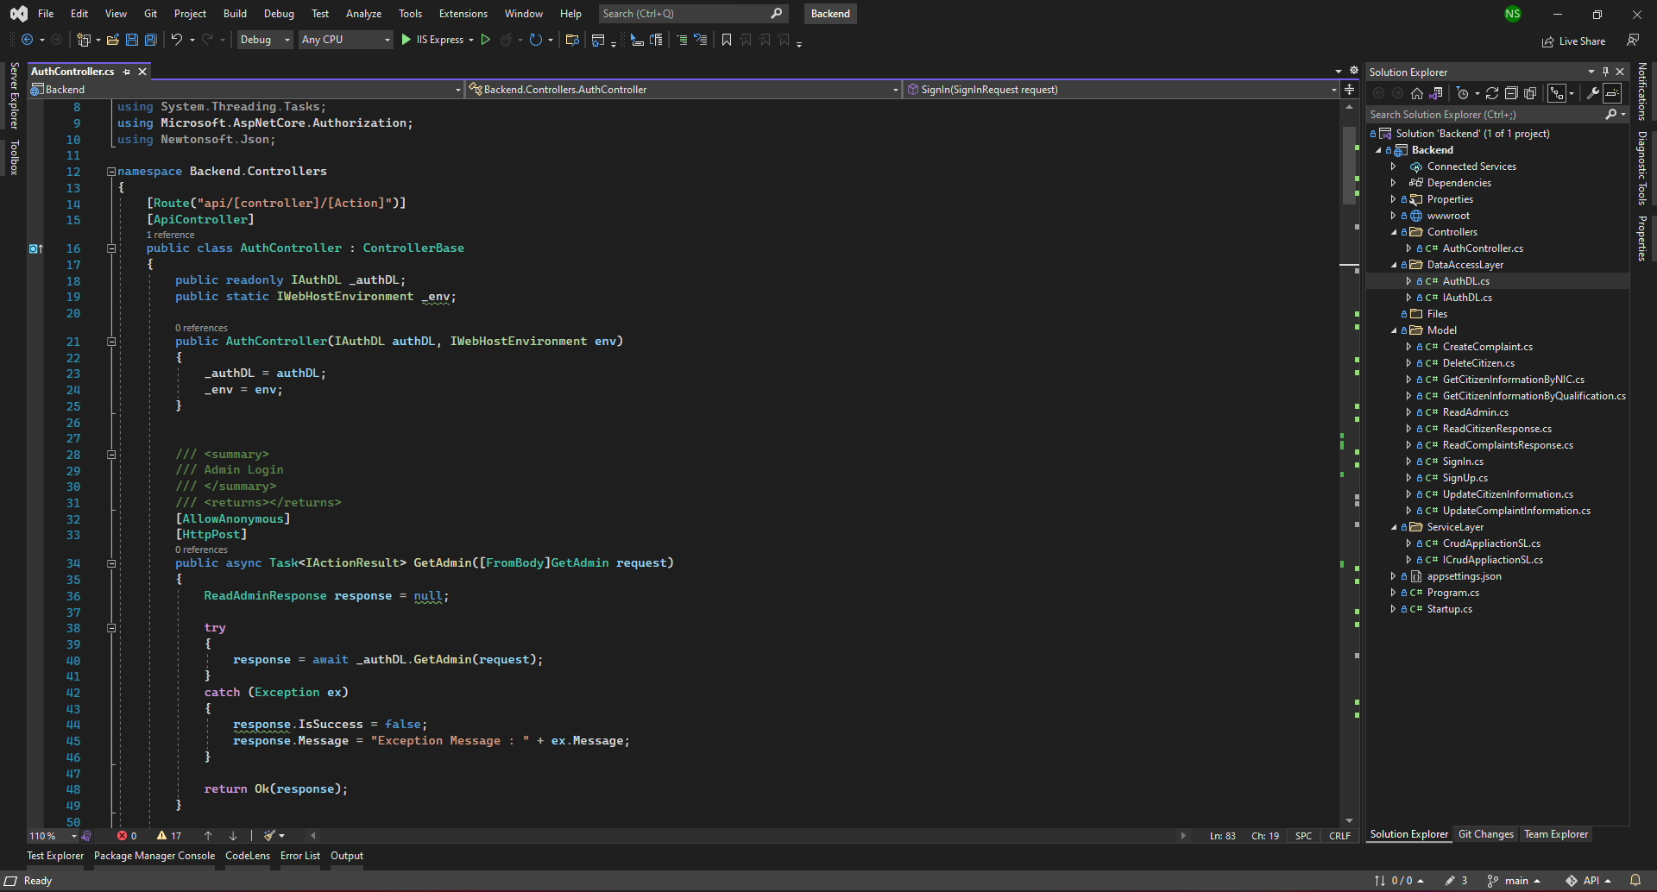

Figure 1 - Admin Sign-In method in the AuthController.cs

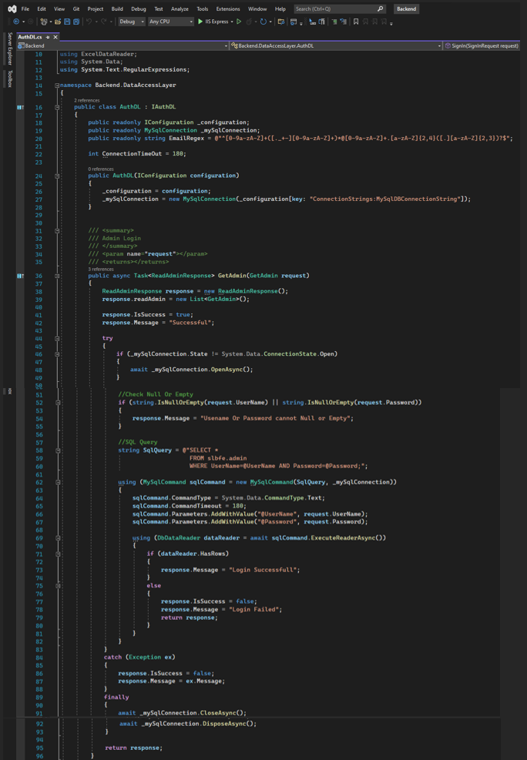

Figure 2 - Admin Sign-In method in the AuthDL.cs

Citizen and Officer Sign-Up

* The below two screenshots represent the Citizen and Officer Sign-Up.

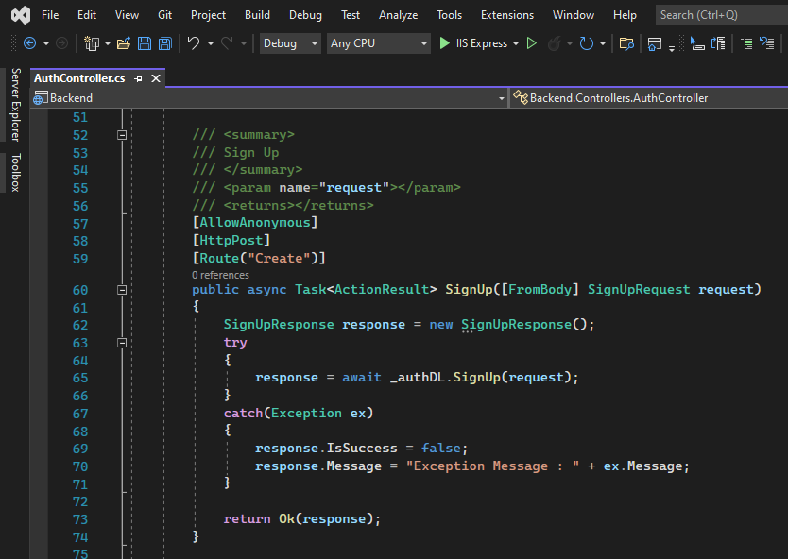

Figure 3 - Citizen & Officer: Sign-Up method in the AuthController.cs

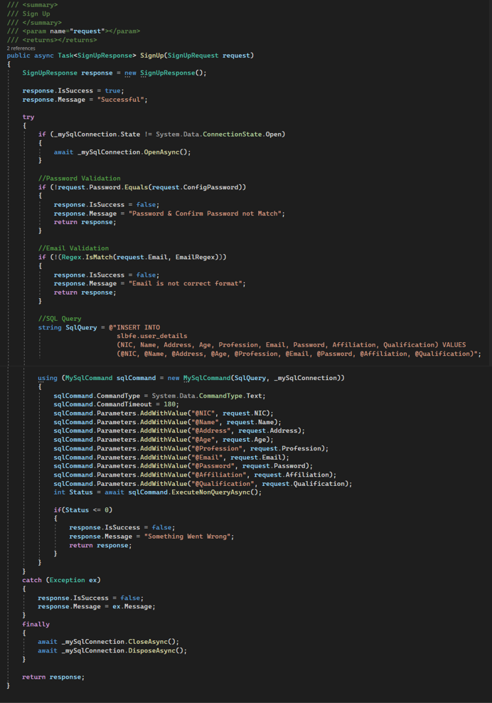

Figure 4- Citizen & Officer: Sign-Up method in the AuthDL.cs

Citizen and Officer Sign-In

* The below two screenshots represent the Citizen and Officer Sign-In.

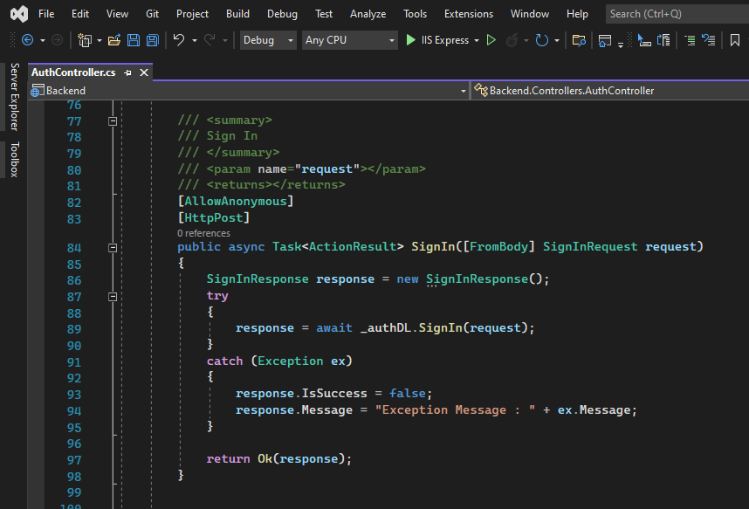

Figure 5 - Citizen & Officer: Sign-In in the AuthController.cs

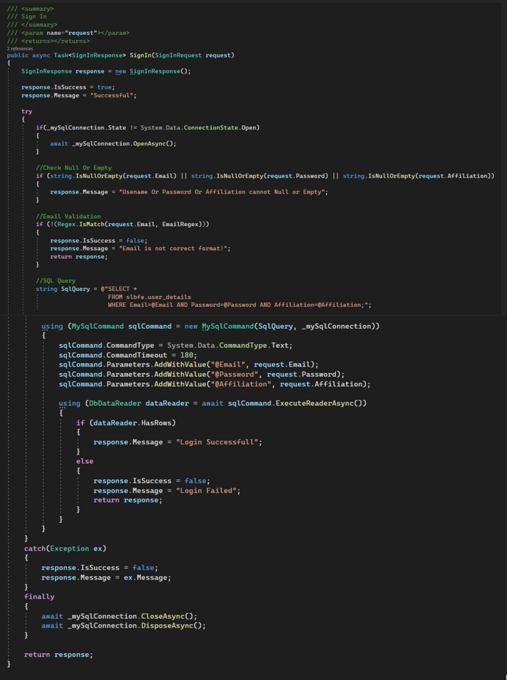

Figure 6 - Citizen & Officer: Sign-In method in the AuthDL.cs

Get List of Citizen Information

* The below two screenshots represent the List of Citizen Information.

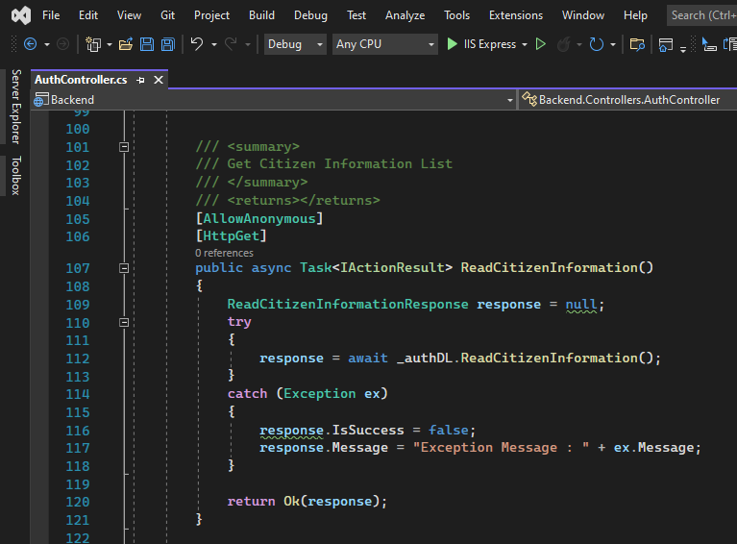

Figure 7 - Read Citizen Information method in the AuthController.cs

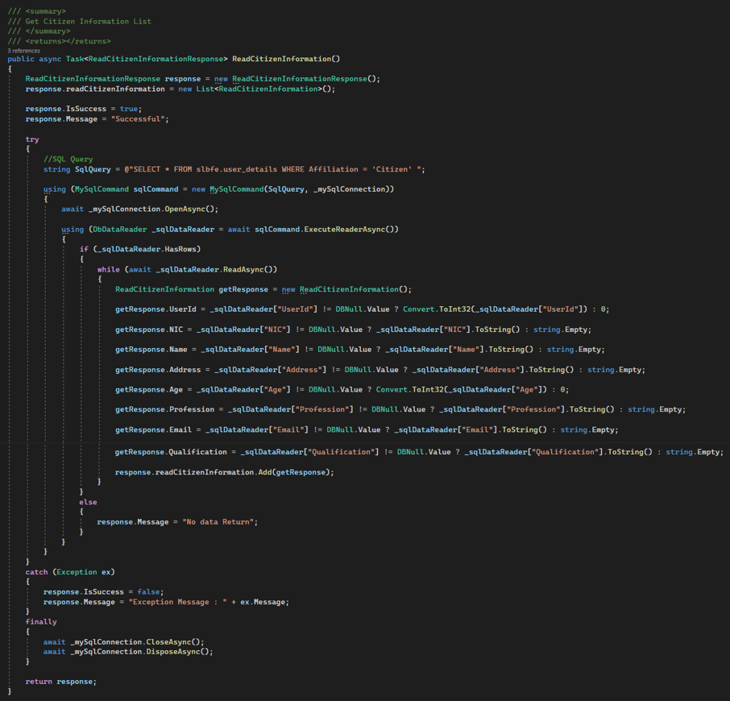

Figure 8 - Read Citizen Information method in the AuthDL.cs

Get Citizen Information By NIC

* The below two screenshots represent the Citizen Information by their NIC.

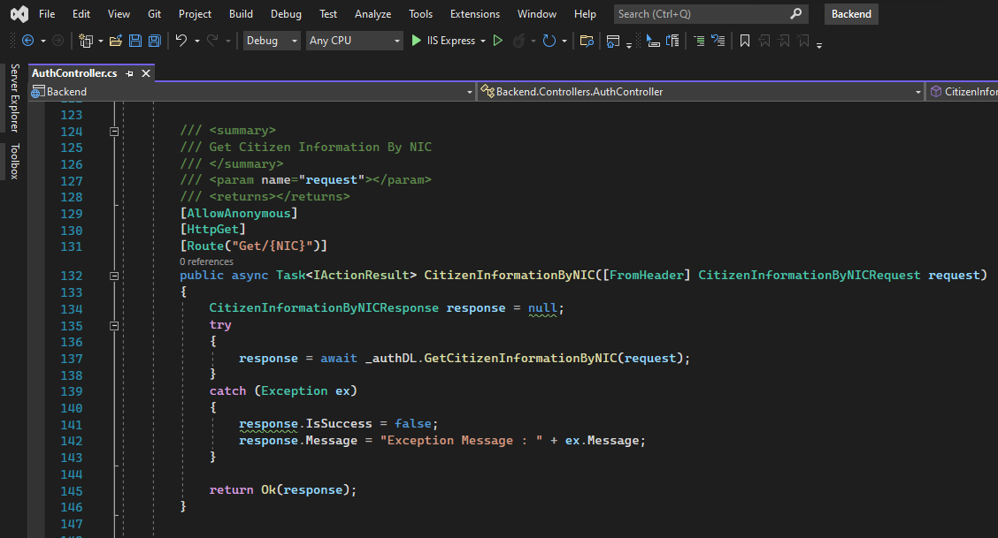

Figure 9 - Citizen Information by NIC method in the AuthController.cs

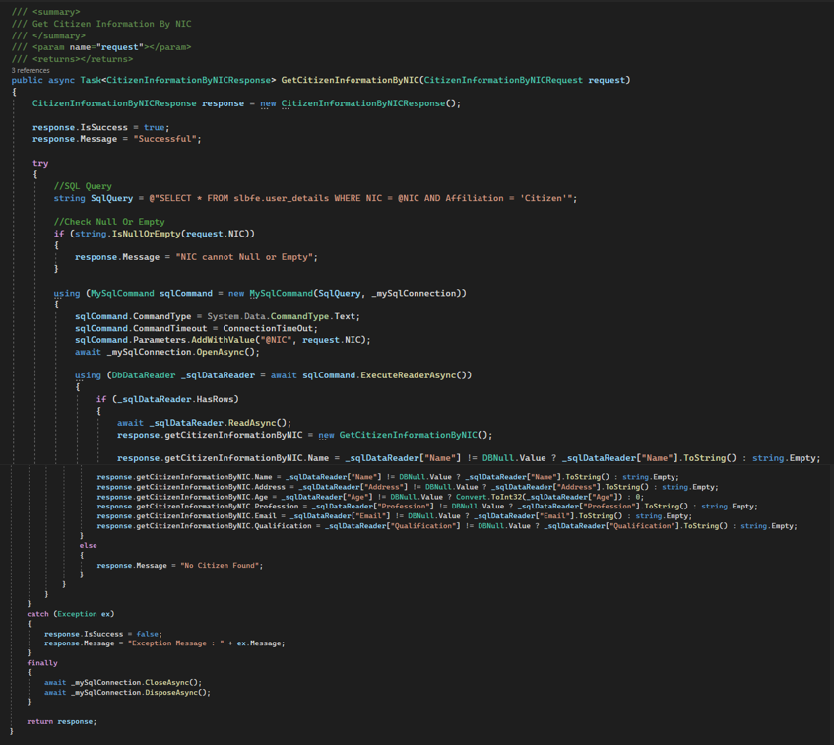

Figure 10 - Citizen Information by NIC method in the AuthDL.cs

Get List of Citizen Information By Qualification

* The below two screenshots represent the List of Citizen Information by their Qualification.

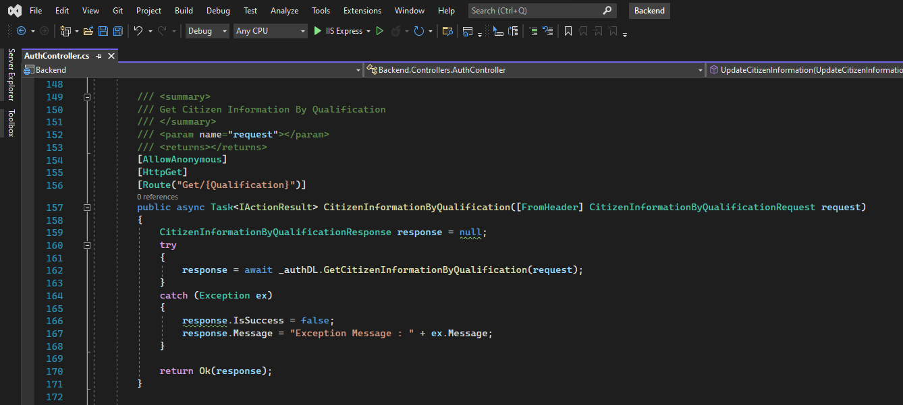

Figure 11 - Citizen Information by Qualification method in the AuthController.cs

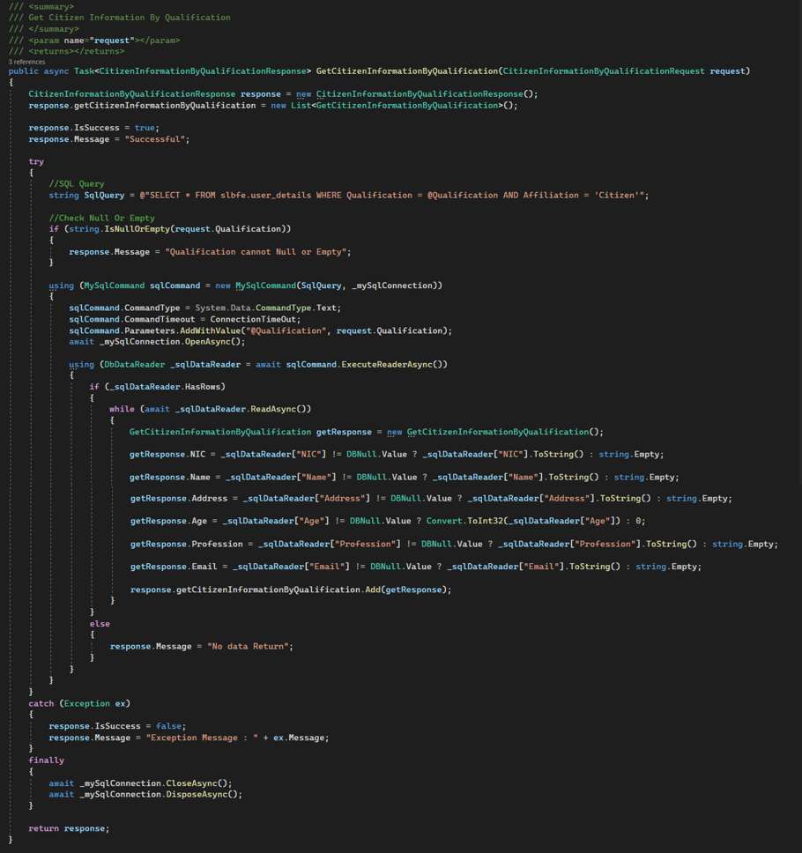

Figure 12 - Citizen Information by Qualification method in the AuthDL.cs

Update Qualification By NIC

* The below two screenshots represent the Update Citizen Qualification by their NIC.

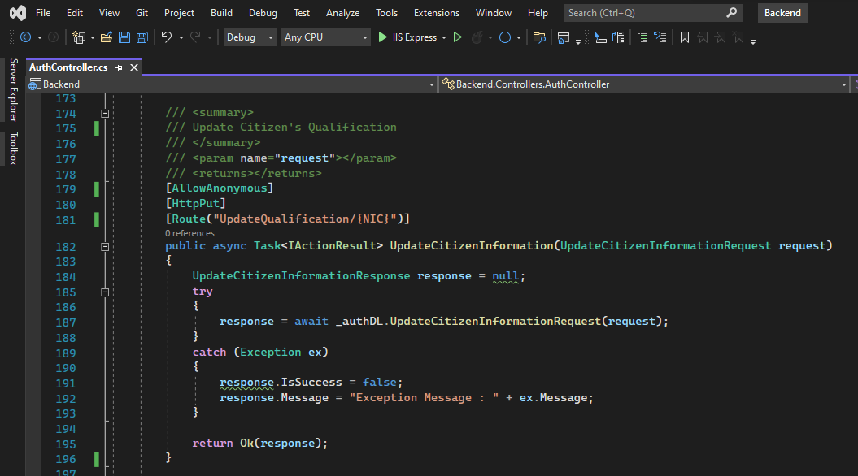

Figure 13 - Update Citizen Information method in the AuthController.cs

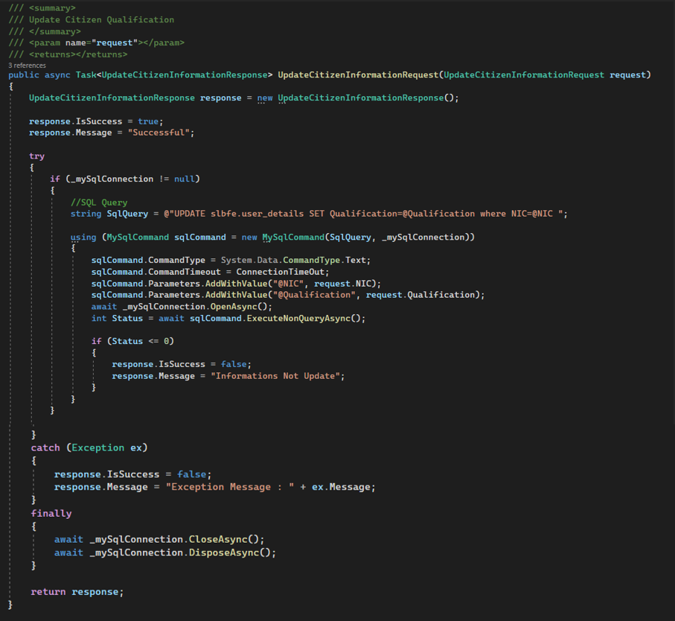

Figure 14 - Update Citizen Information method in the AuthDL.cs

Upload Citizen Documents

* The below screenshot represents the Upload Citizen Documents.

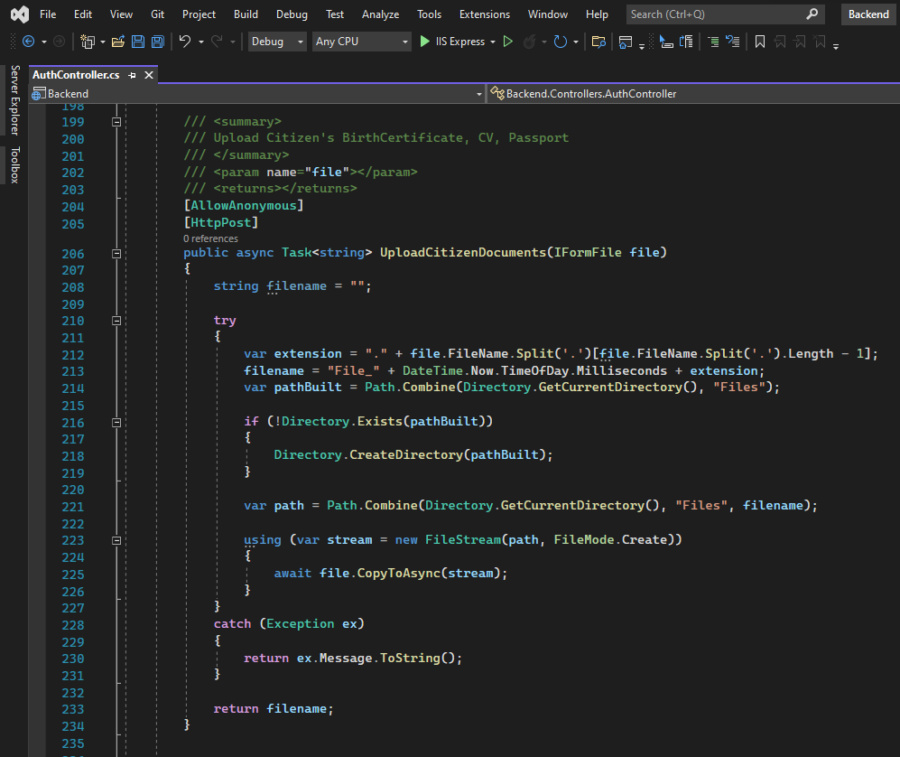

Figure 15 - Upload Citizen Documents method in the AuthController.cs

Delete Citizen Account by UserId

* The below two screenshots represent the Delete Citizen Account by UserId.

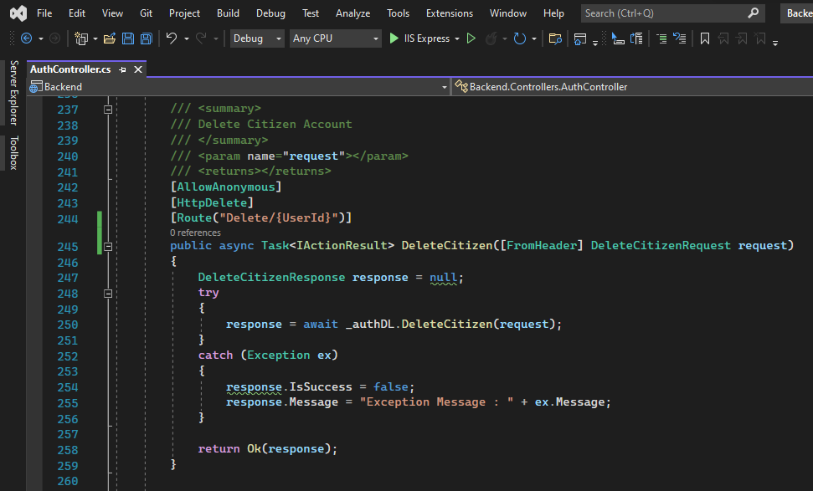

Figure 16 - Delete Citizen method in the AuthController.cs

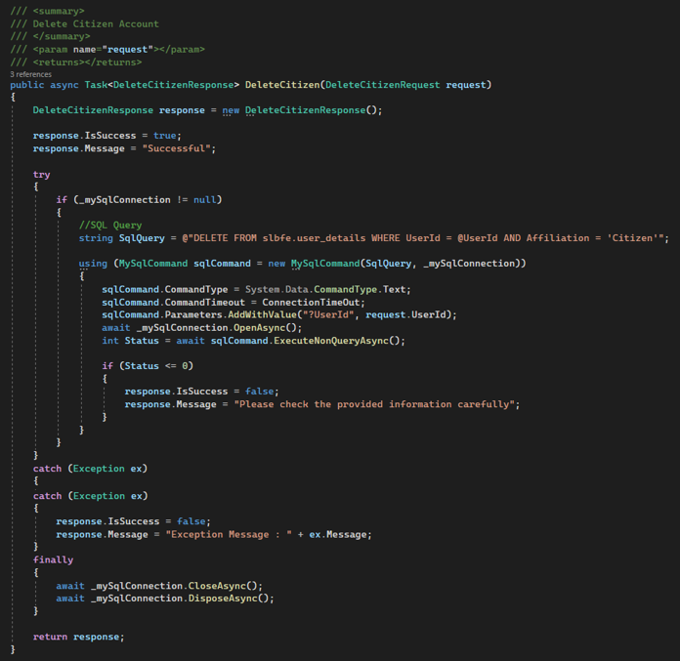

Figure 17 - Delete Citizen method in the AuthDL.cs

Read Complaints

* The below two screenshots represent the List of Citizen’s Complaints.

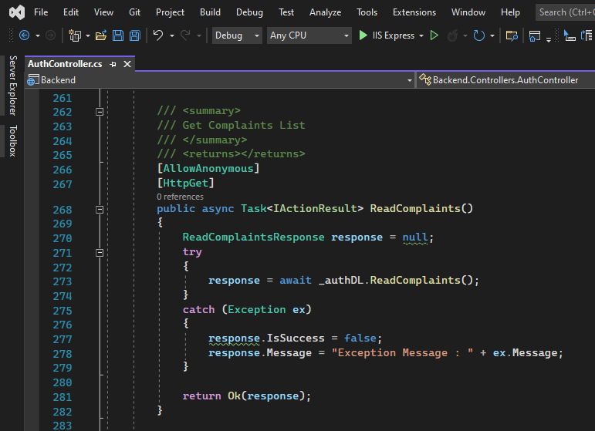

Figure 18 - Read Complaints method in the AuthController.cs

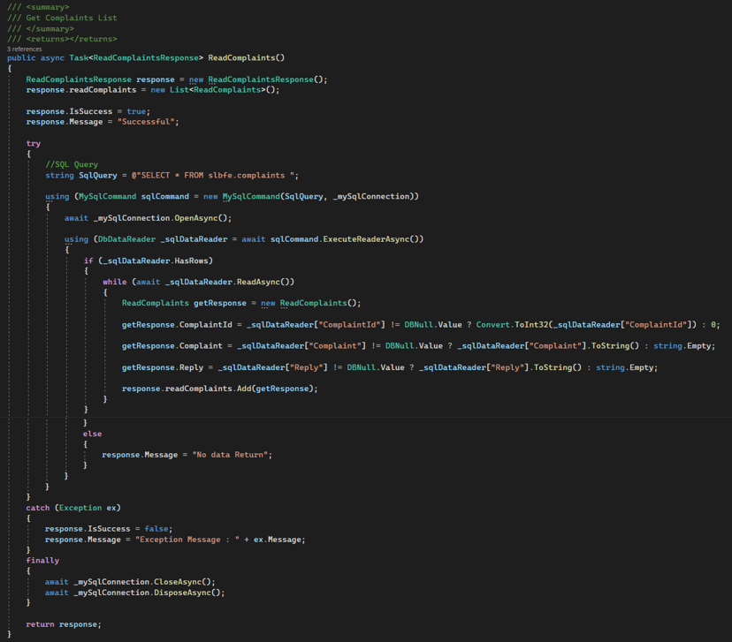

Figure 19 - Read Complaints method in the AuthDL.cs

Create a Complaint

* The below two screenshots represent the create a Complaint.

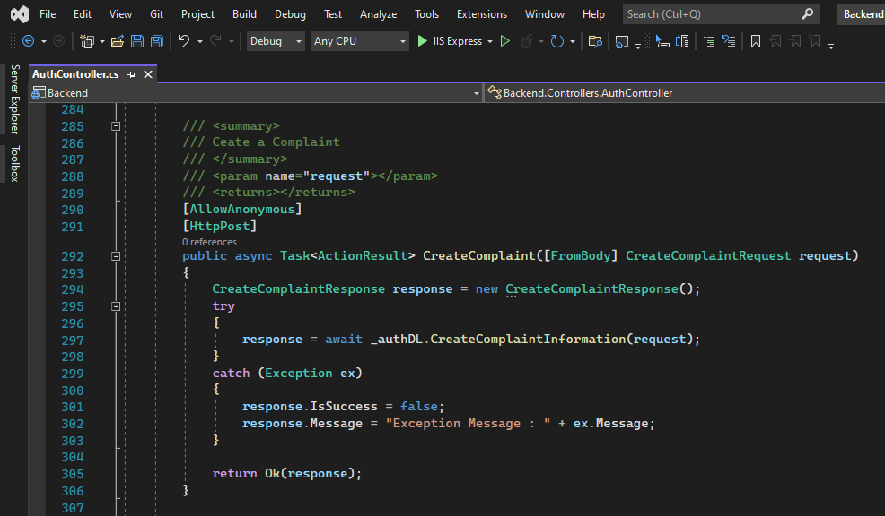

Figure 20 - Create Complaint method in the AuthController.cs

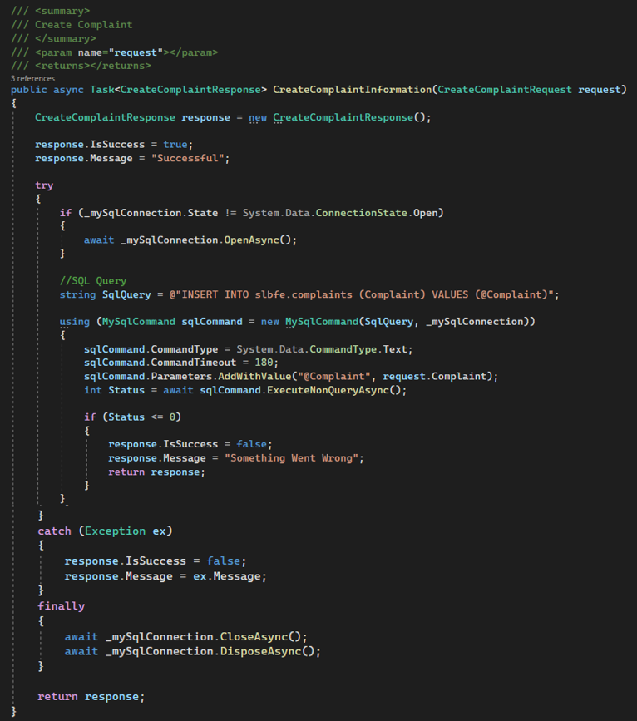

Figure 21 - Create Complaint method in the AuthDL.cs

Reply for a Complaint

* The below two screenshots represent the Reply to the Citizen’s Complaints.

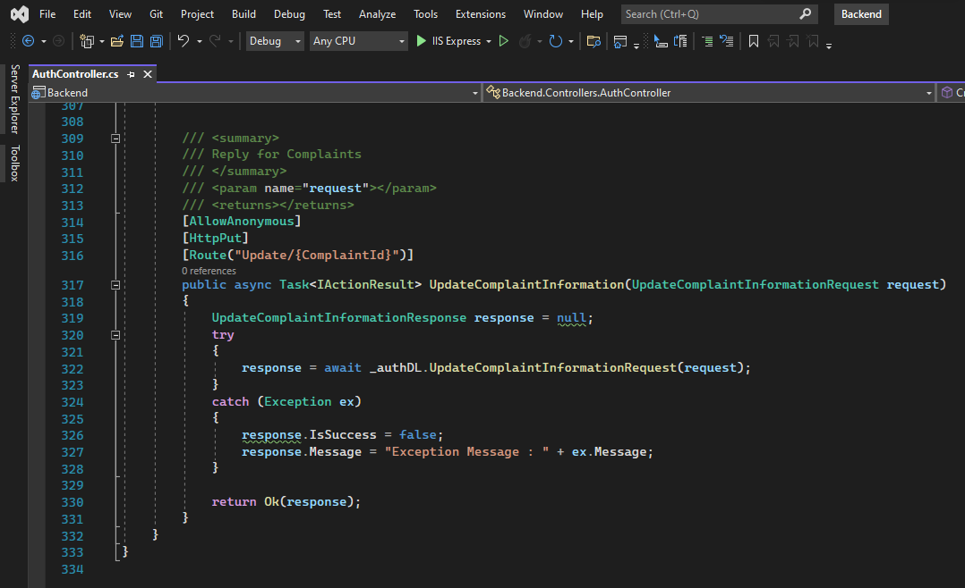

Figure 22 - Update Complaint Information method in the AuthController.cs

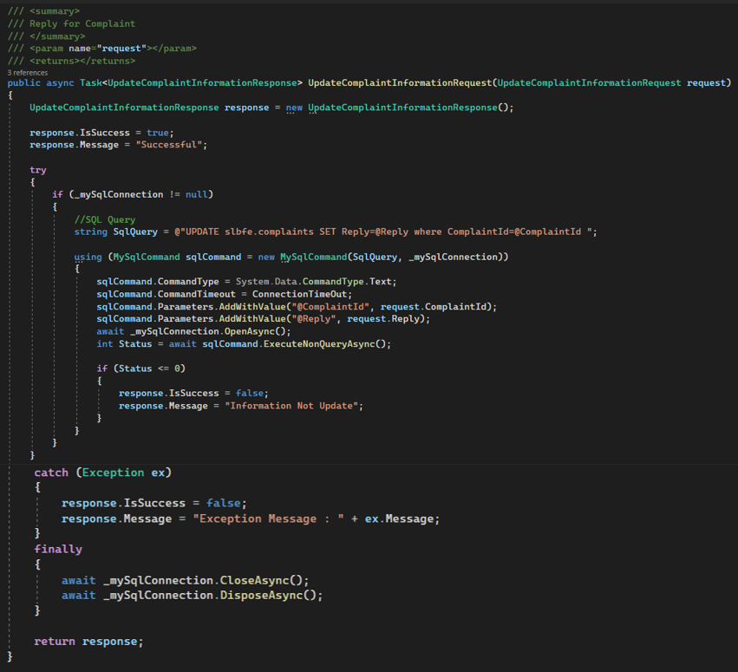

Figure 23 - Update Complaint Information method in the AuthDL.cs

### 2.2.1.2. Mobile Application

* When creating the mobile application the same .NET backend was used and then the application and the APIs was called through the application.

Import Retrofit Dependency

* Imported Retrofit dependencies to make a request and response communication between the front end and the APIs.

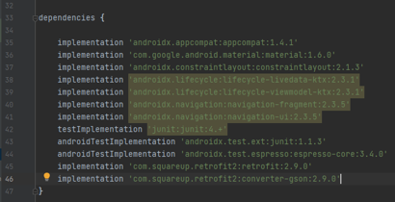

Models

User model

* Defined the variables of the user using a public class.

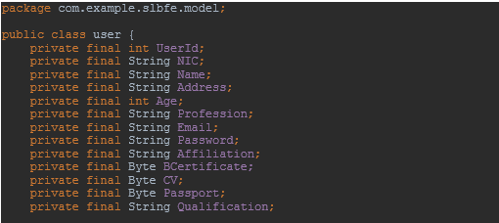

* Assigned values for the defined variables.

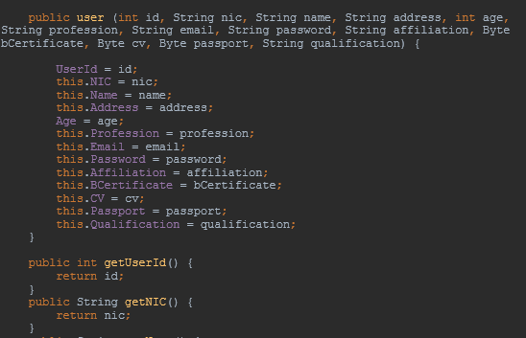

* Accessed the private variables through a public function.

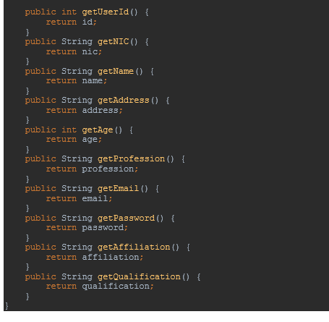

Complaint Model

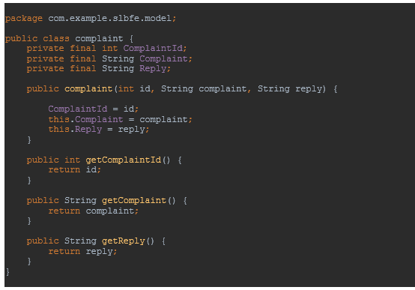

Admin Model

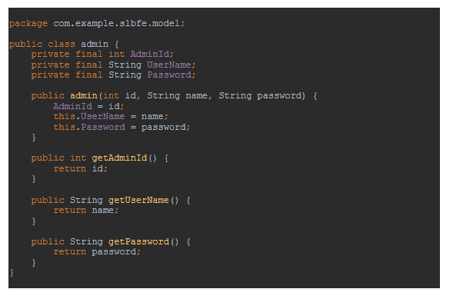

Retrofit 2 service and Interface

* Calling APIs.

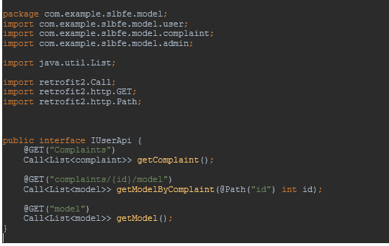

Retrofit instance

* Connection setup

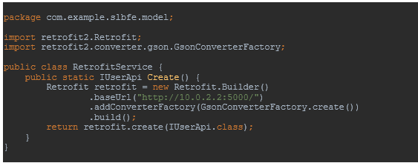

API Manager

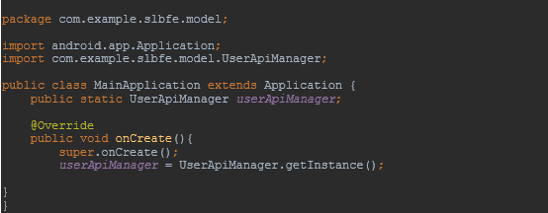

ModelsAPI Manager

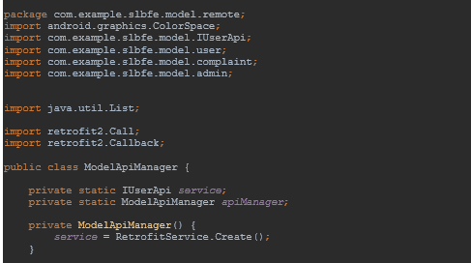

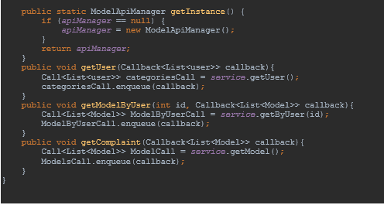

The repository

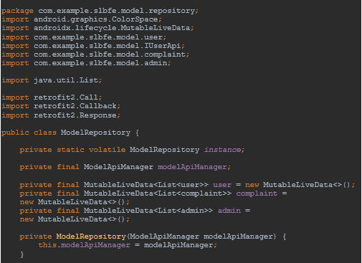

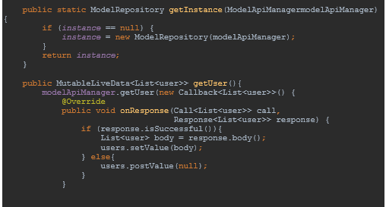

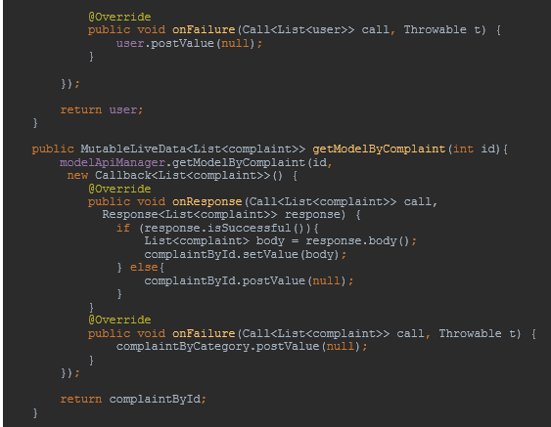

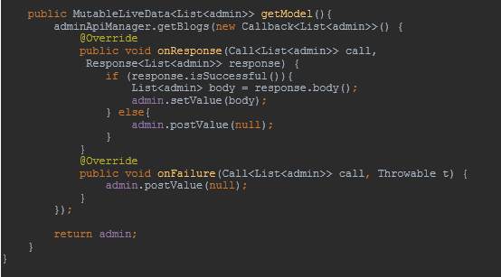

### Run-Time Screenshots

* The JSON output is displayed in the Swagger and the XML output is displayed with Postman.
* The integrated application is given to the users in which all the APIs are able to be controlled from the frontend.

#### Web APPLICATION

Citizen & Officer - Sign-Up Page

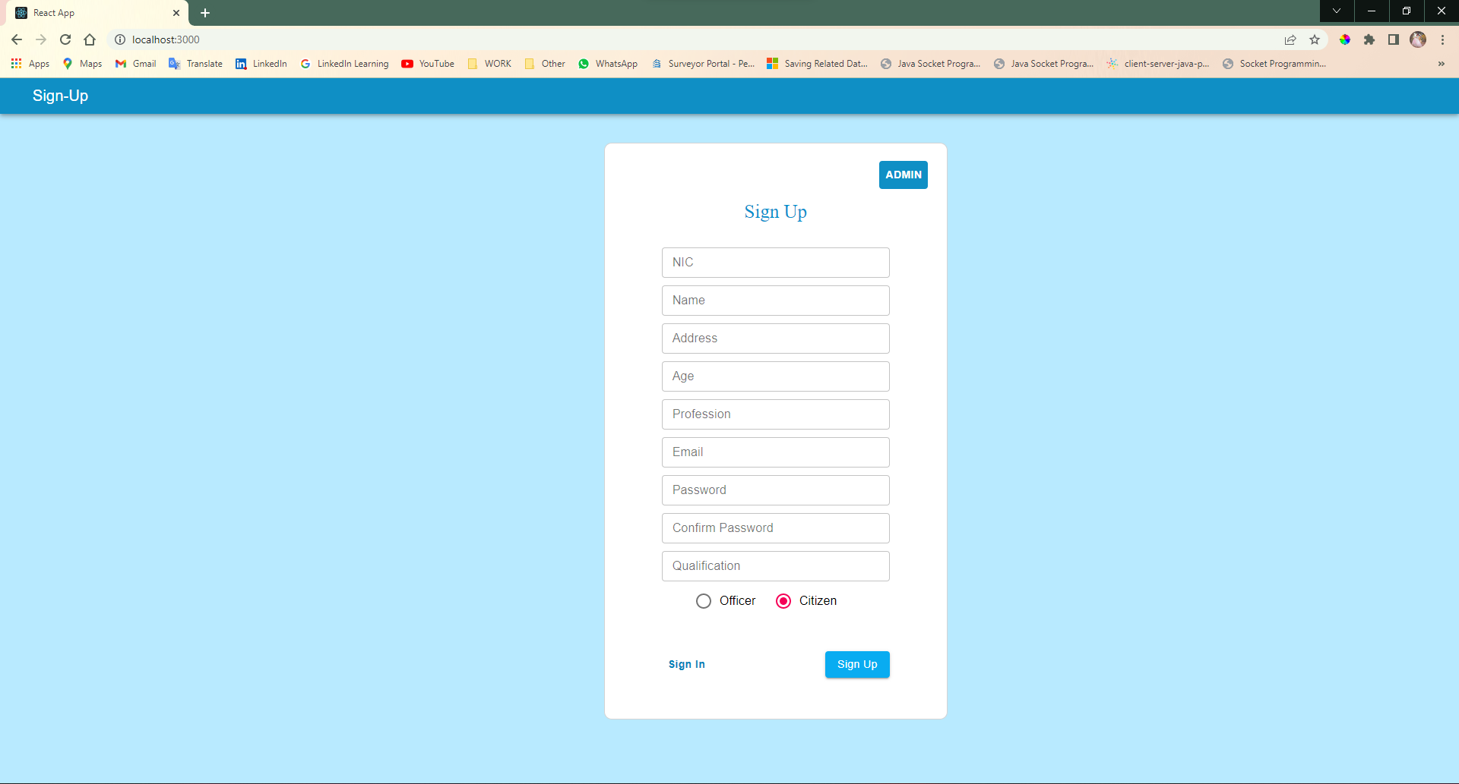

Figure 24 - Run-Time: Citizen & Officer Sign-Up User-Interface

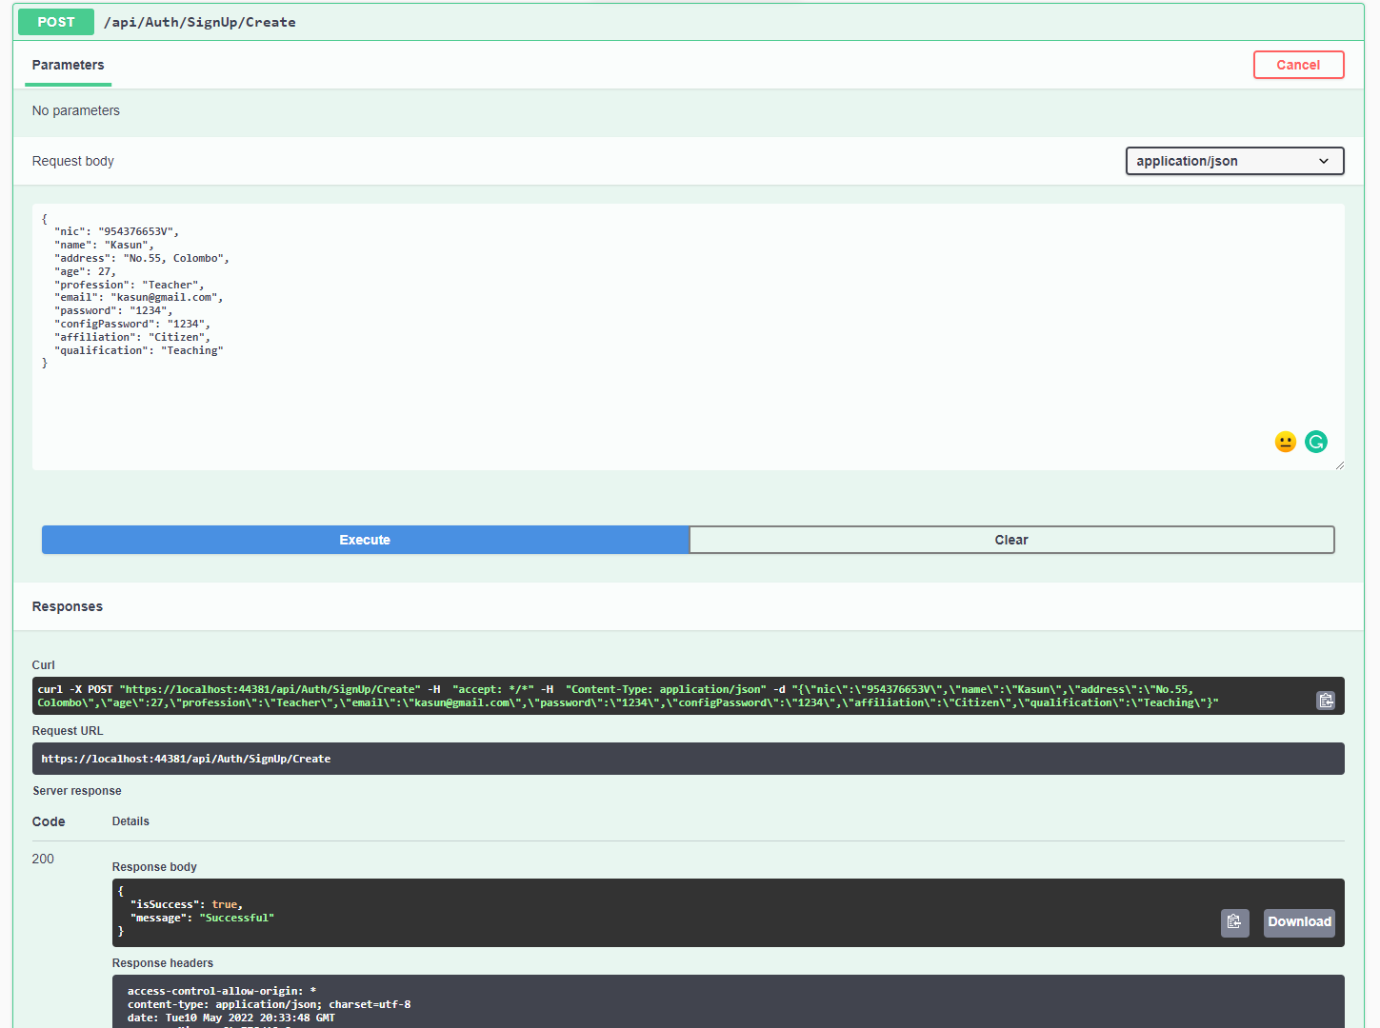

Figure 25 - Run-Time: Citizen & Officer Sign-Up with JSON result

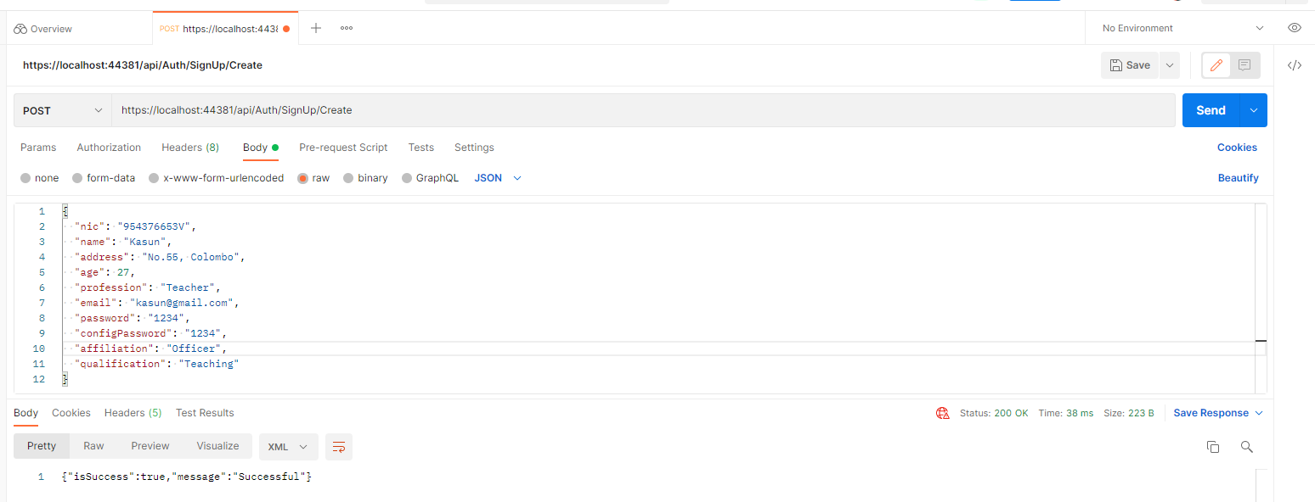

Figure 26 - Run-Time: Citizen & Officer Sign-Up with XML result

Citizen & Officer - Sign-In Page

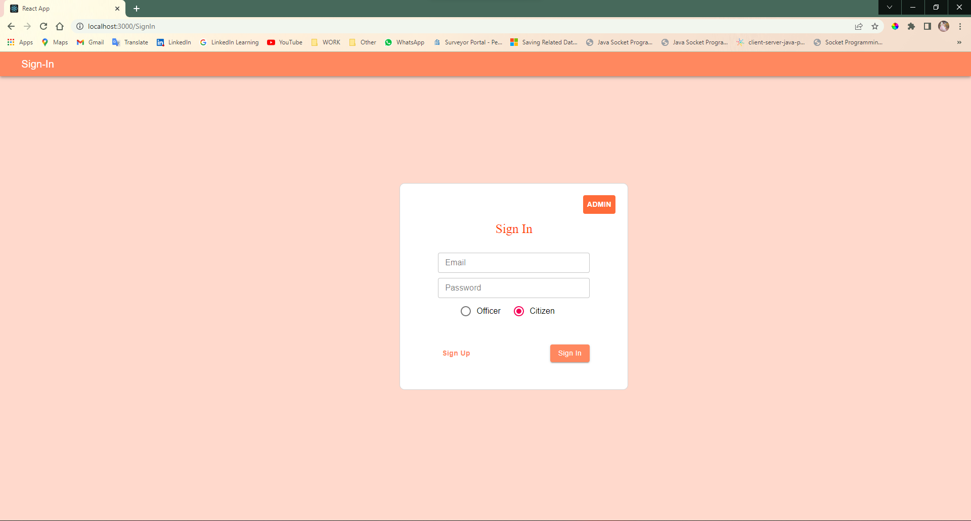

Figure 27 - Run-Time: Citizen & Officer Sign-In Use-Interface

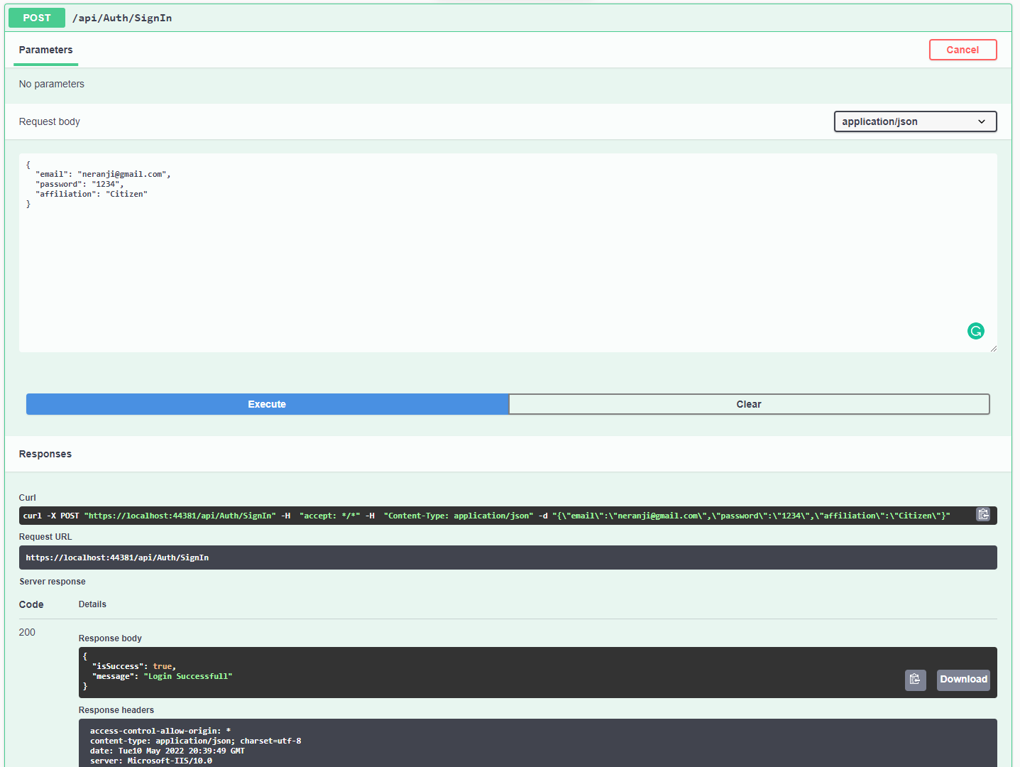

Figure 28 - Run-Time: Citizen & Officer Sign-In with JSON result

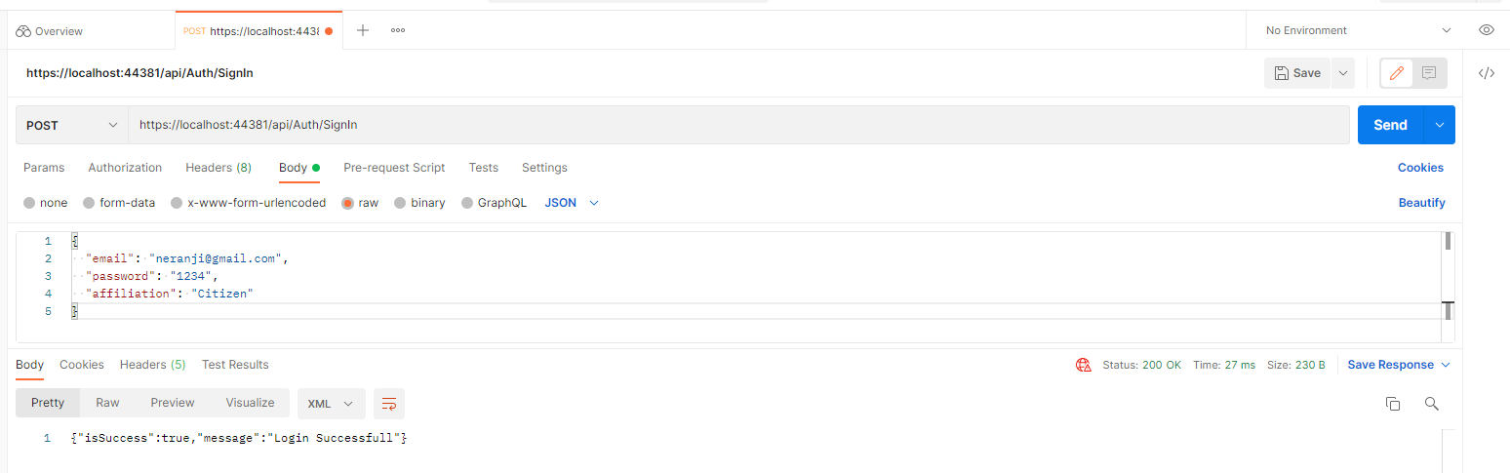

Figure 29 - Run-Time: Citizen & Officer Sign-In with XML result

Admin Sign-In Page

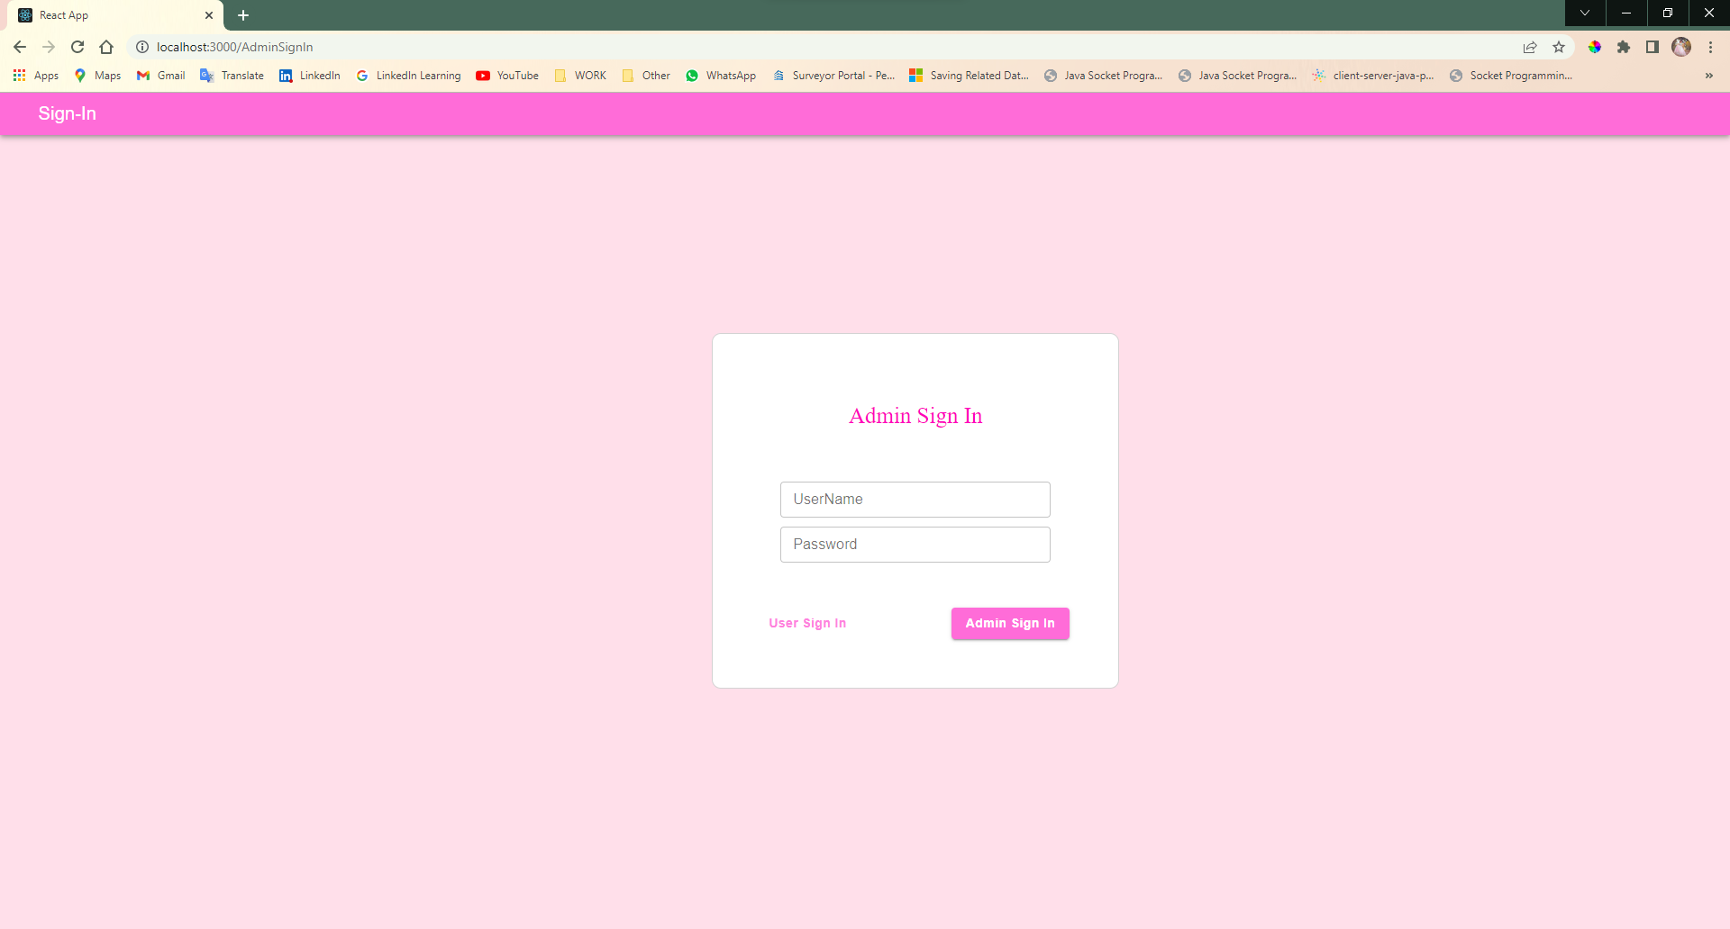

Figure 30 - Run-Time: Admin Sign-In User-Interface

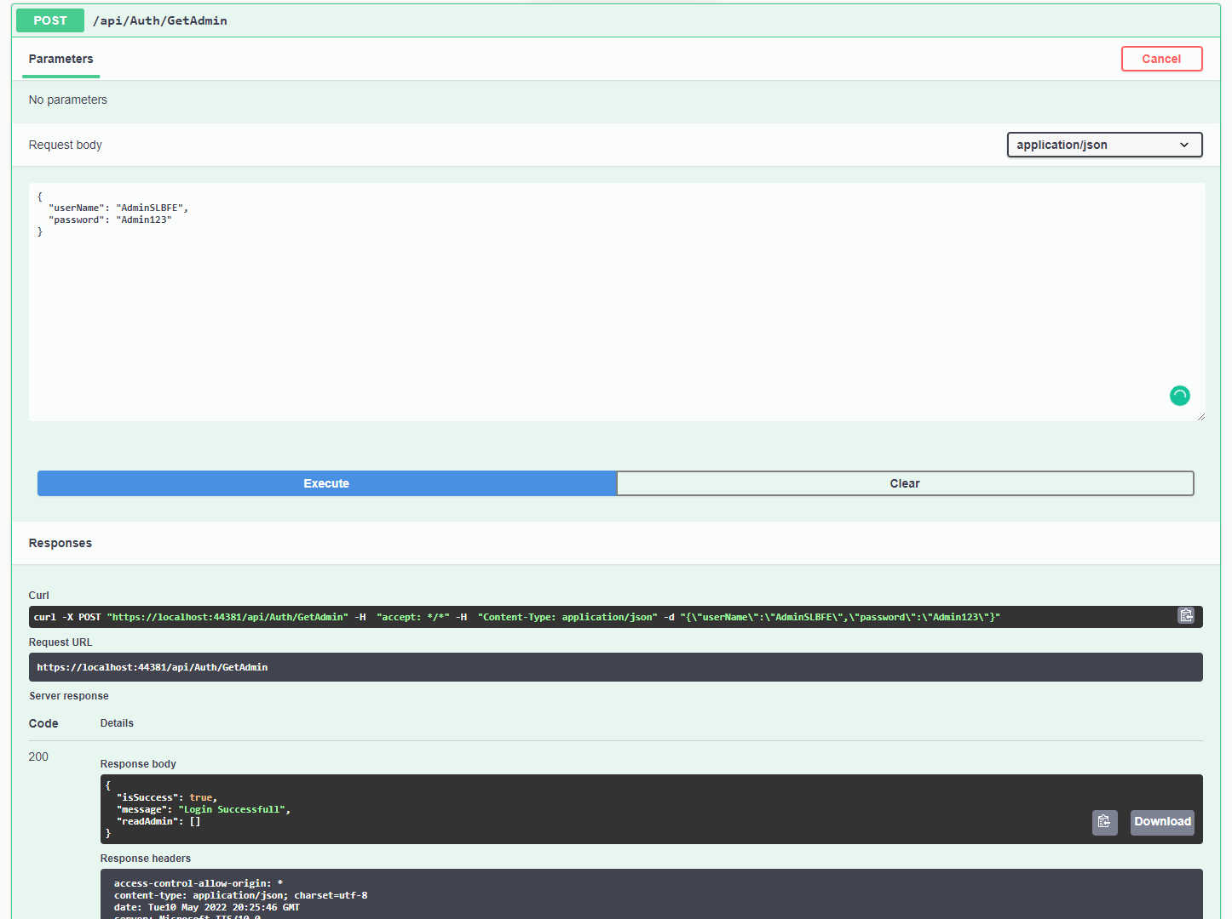

Figure 31 - Run-Time: Admin Sign-In with JSON result

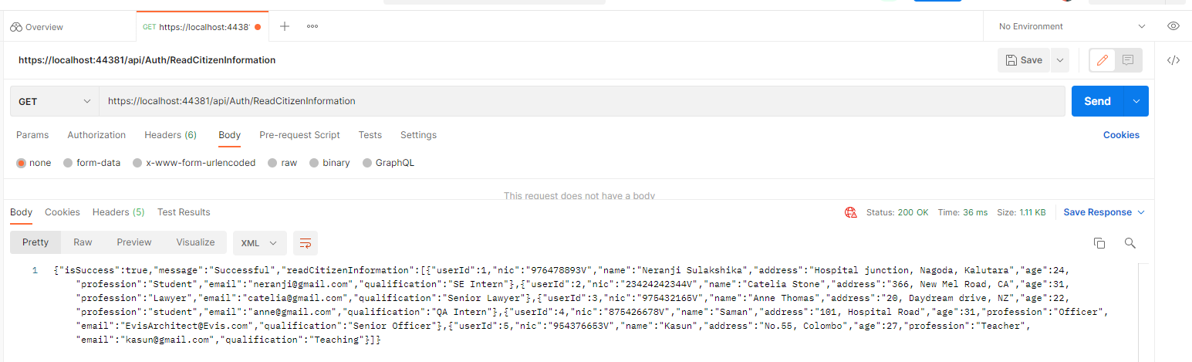

Figure 32 - Run-Time: Admin Sign-In with XML result

Admin Home Page

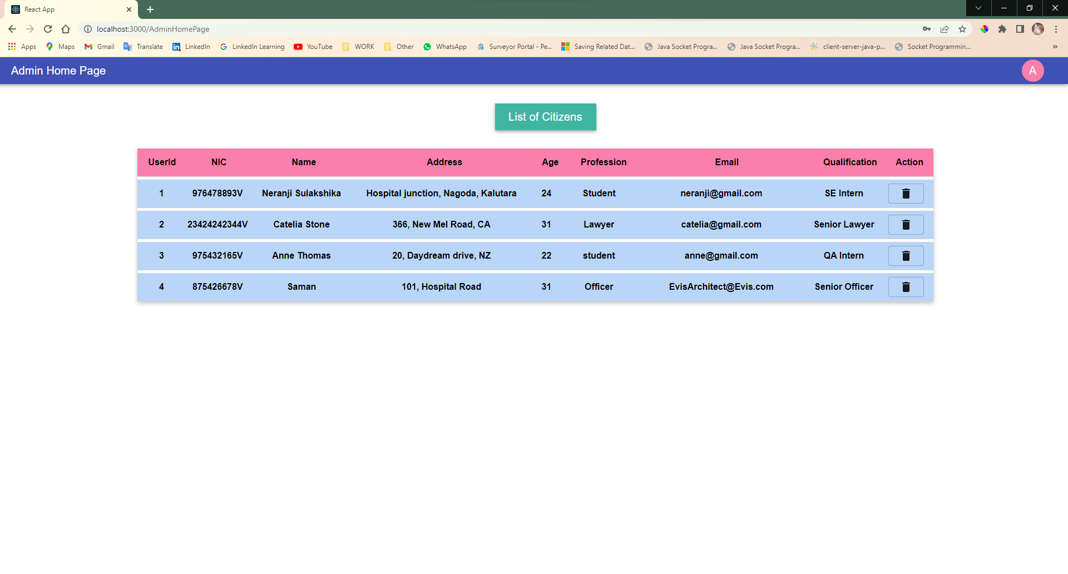

Figure 33 - Admin Home User-Interface

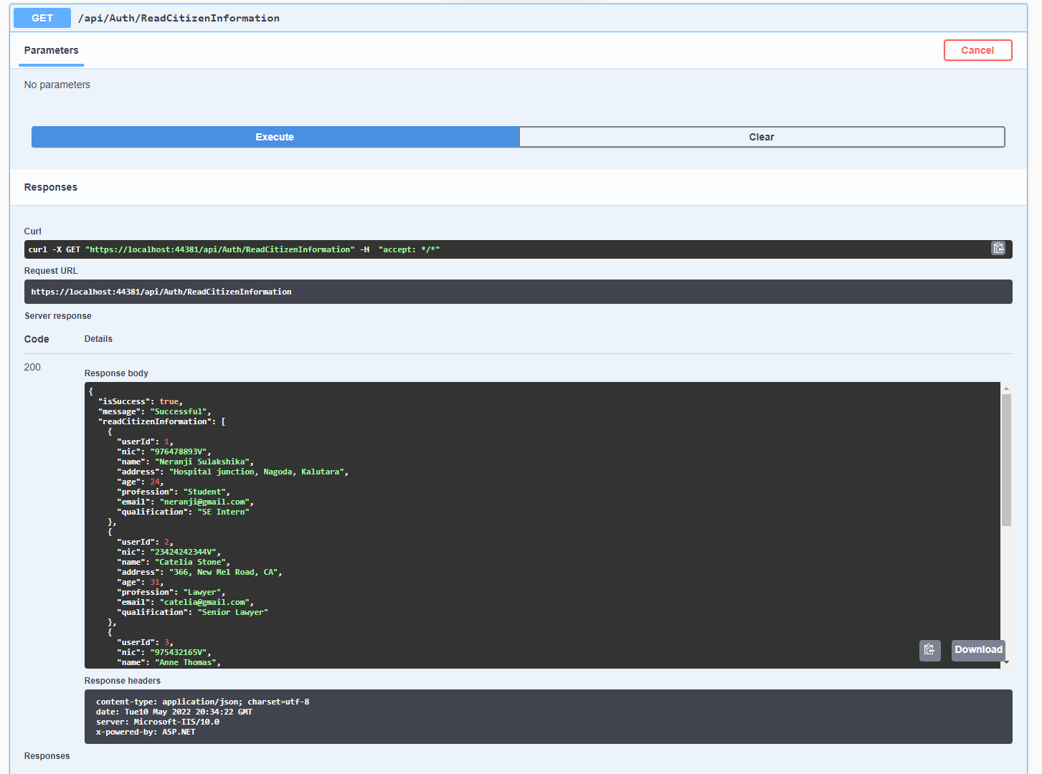

Figure 34 - Run-Time: List of Citizen Information with JSON result

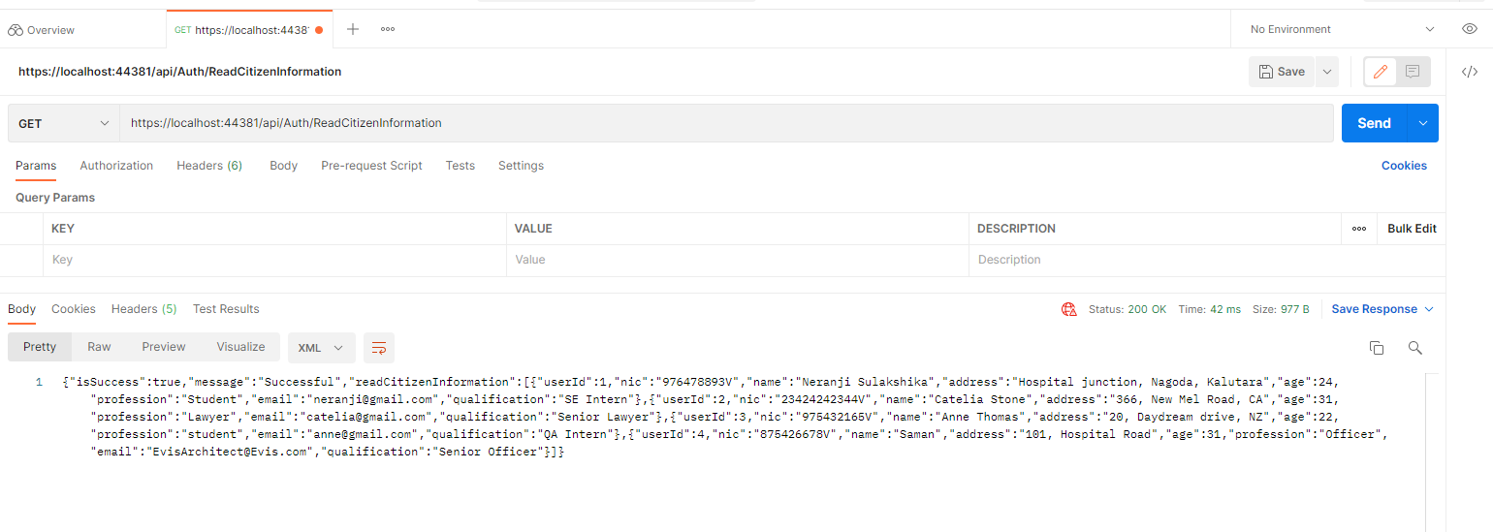

Figure 35 - Run-Time: List of Citizen Information with XML result

Find Citizen Information by NIC

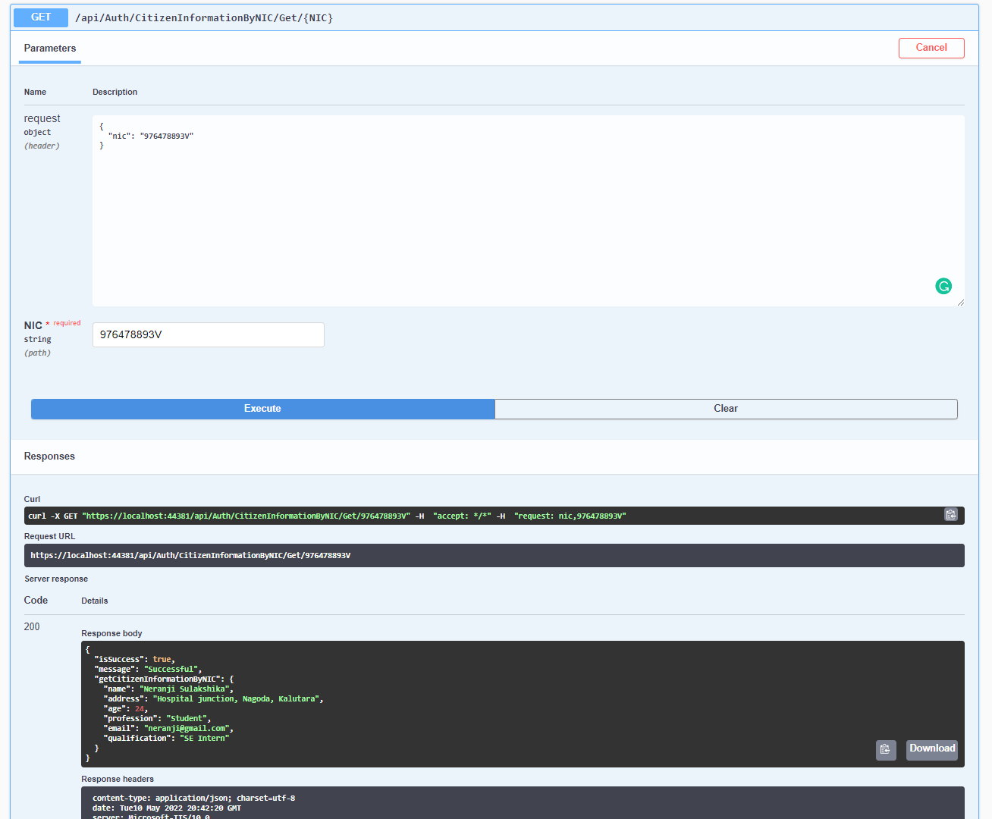

Figure 36 - Run-Time: Get Citizen Information by NIC with JSON result

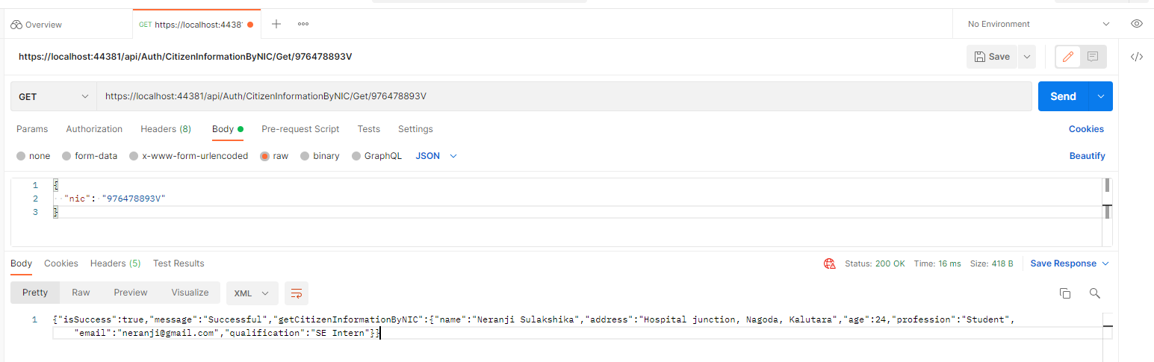

Figure 37 - Run-Time: Get Citizen Information by NIC with XML result

Find Citizen Information by Qualification

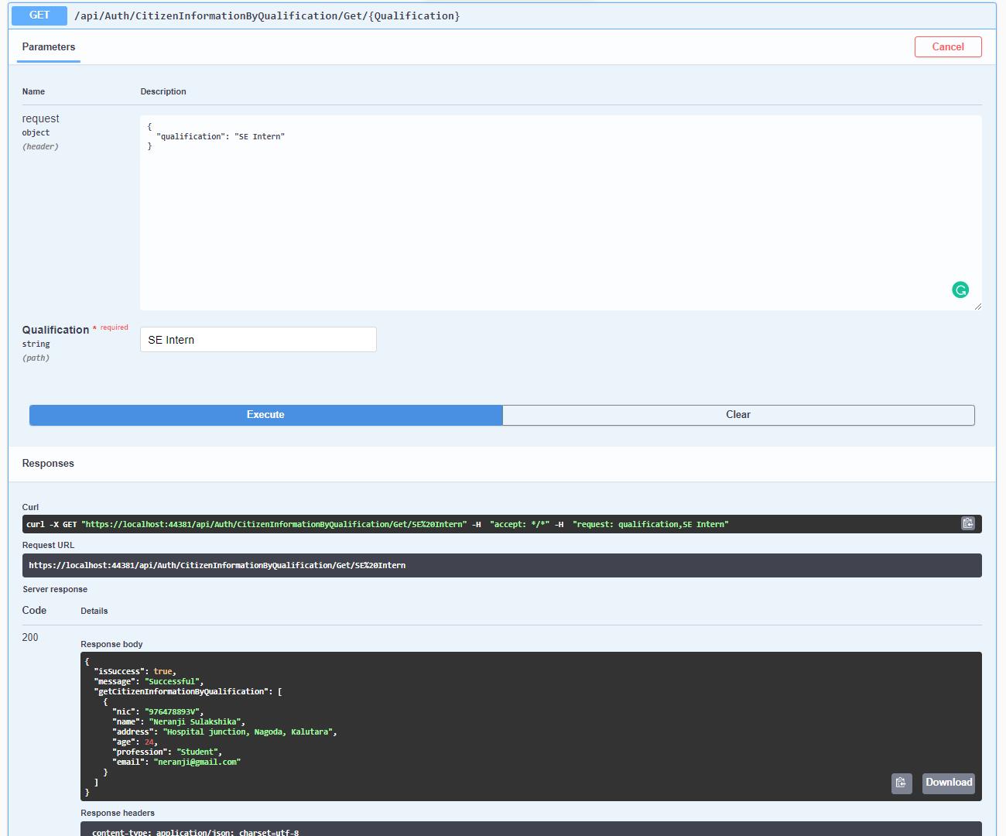

Figure 38 - Run-Time: Get Citizen Information by Qualification with JSON result

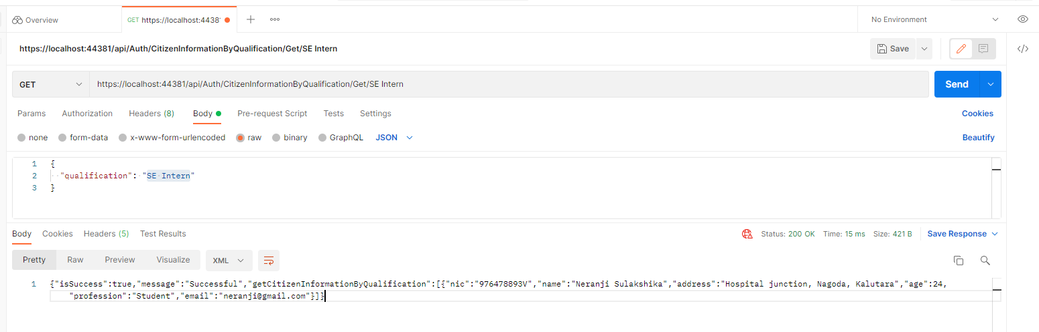

Figure 39 - Run-Time: Get Citizen Information by Qualification with XML result

Update Citizen Qualification by NIC

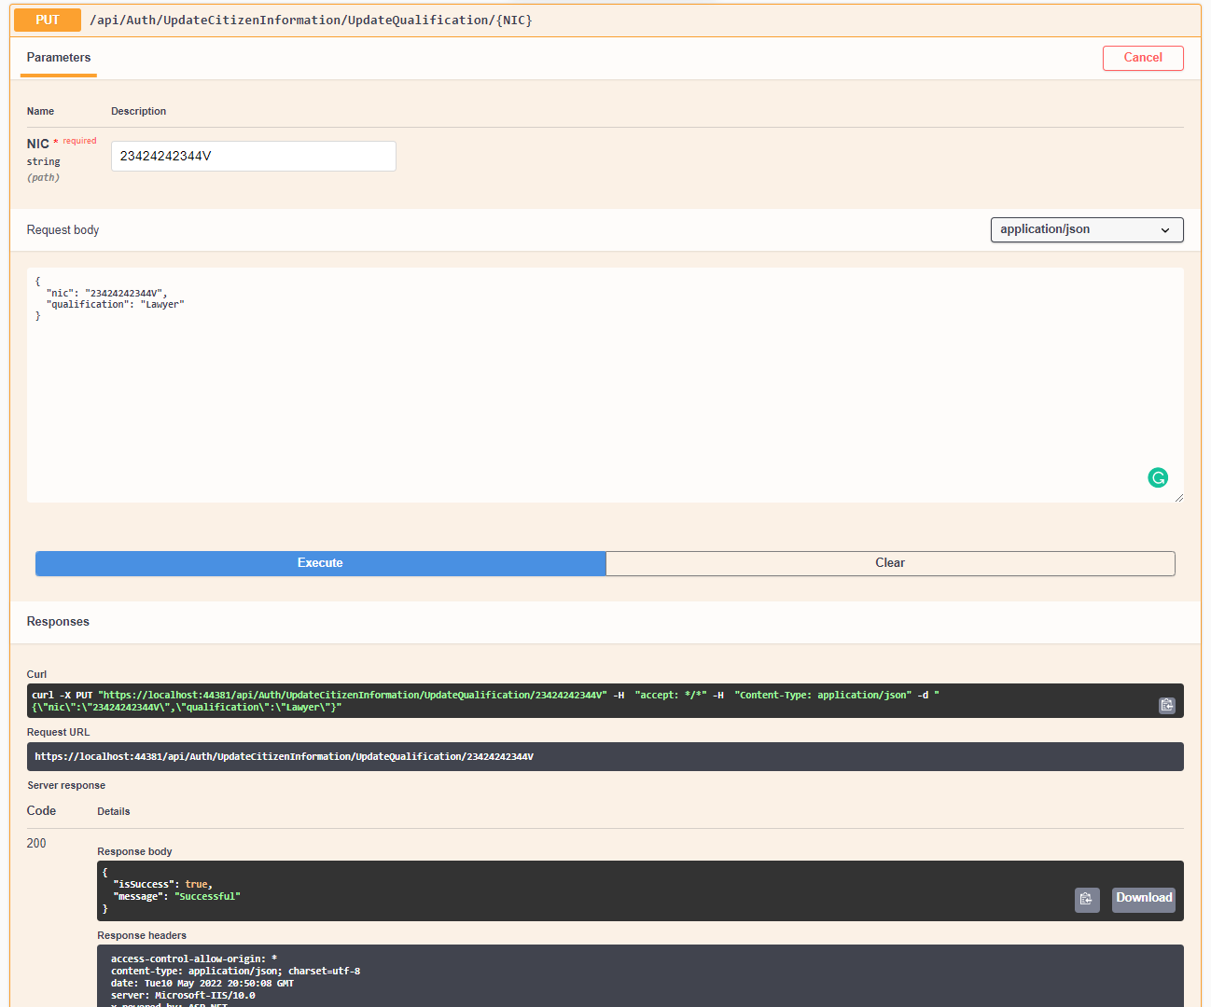

Figure 40 - Run-Time: Update Citizen Qualification by NIC with JSON result

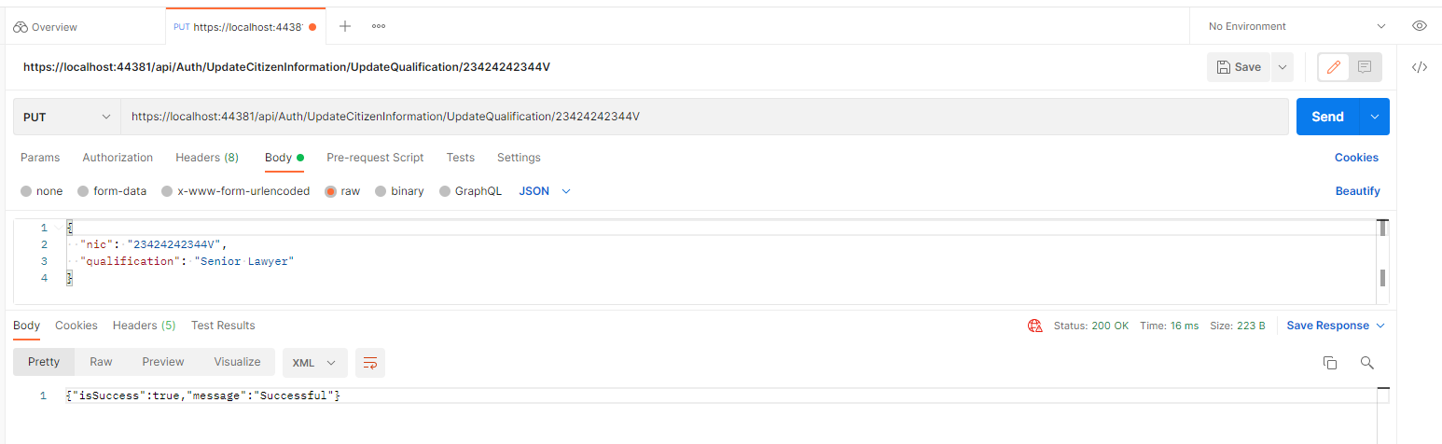

Figure 41 - Run-Time: Update Citizen Qualification by NIC with XML result

Upload Citizen Documents

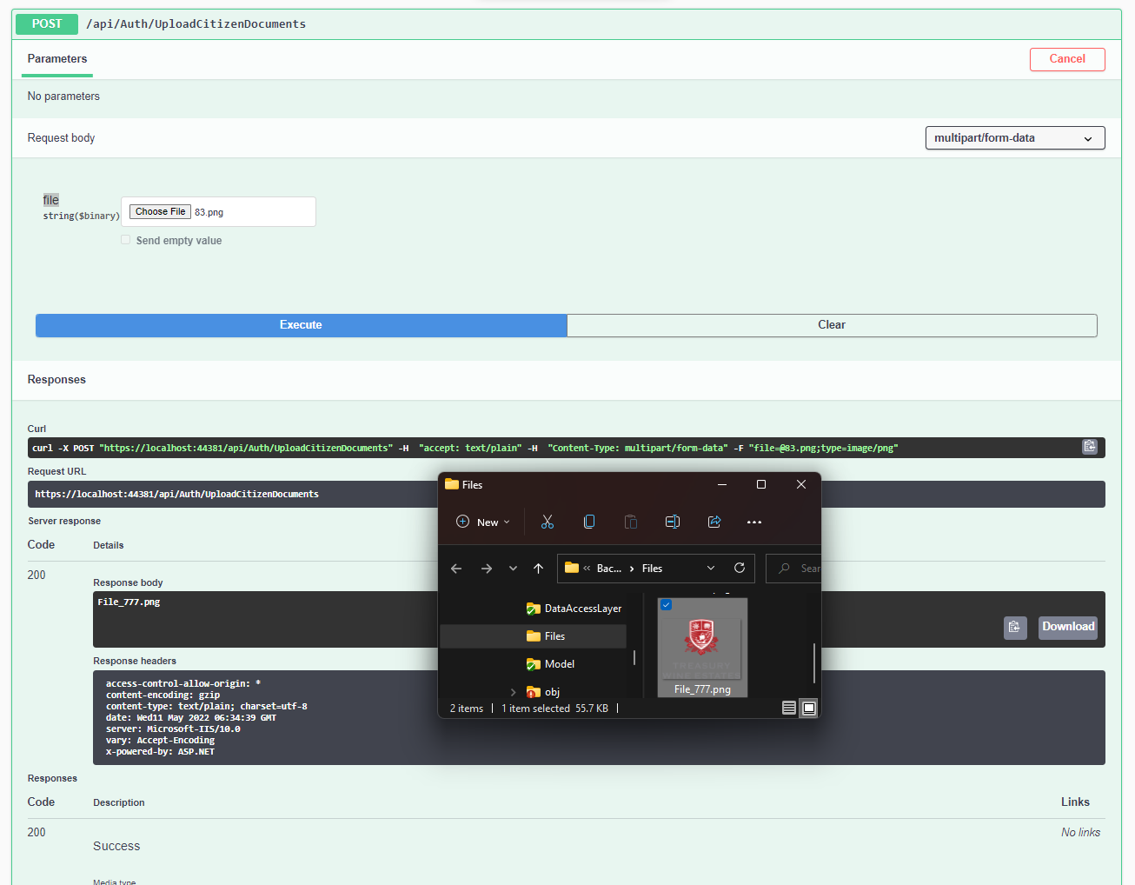

Figure 42 - Run-Time: Upload Citizen Documents with JSON result

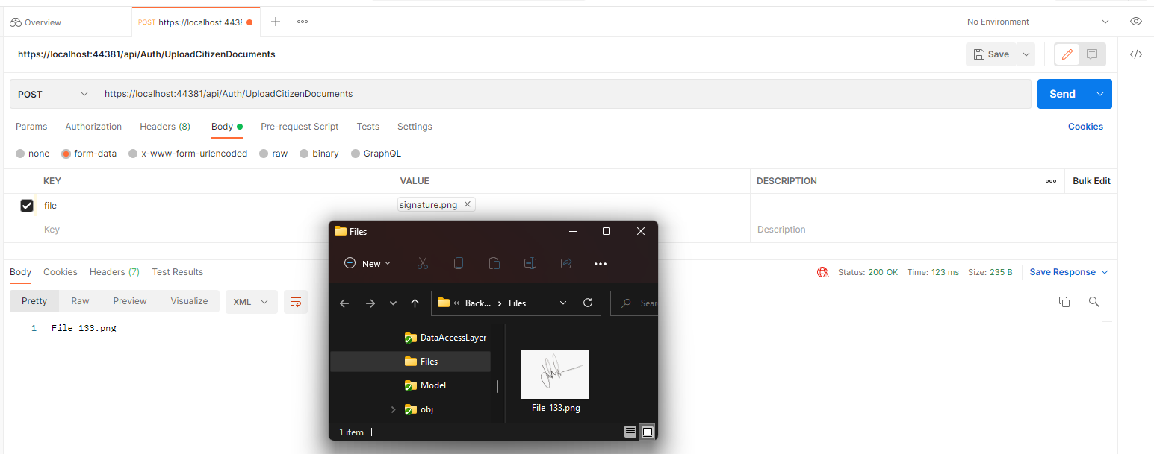

Figure 43 - Run-Time: Upload Citizen Documents with XML result

Delete Citizen Account

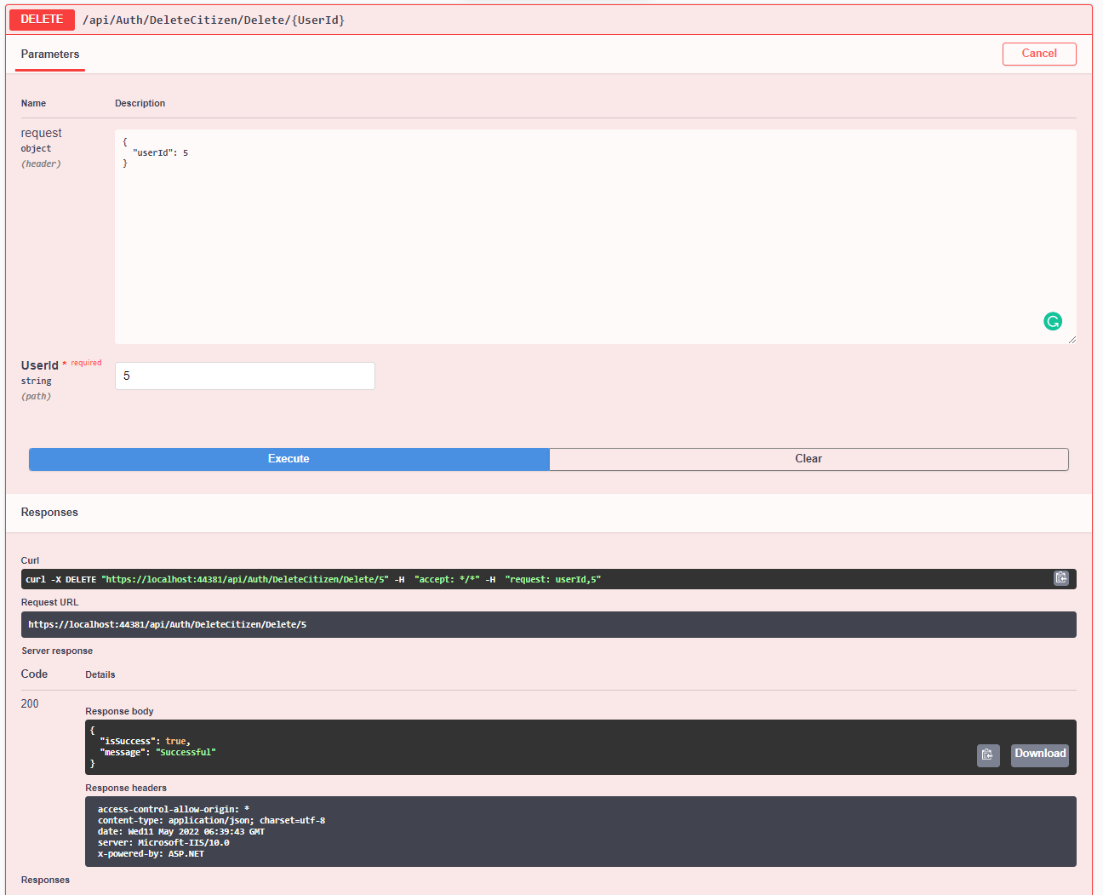

Figure 44 - Run-Time: Delete Citizen Account with JSON result

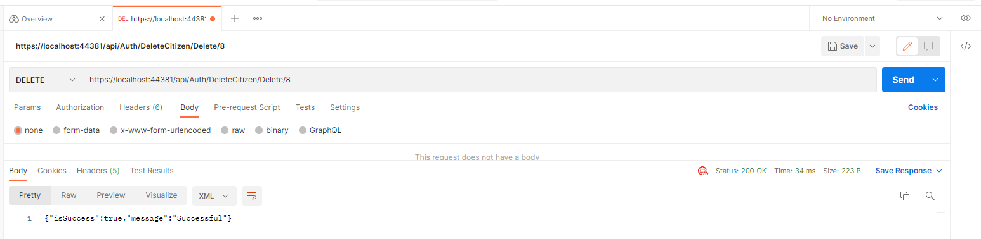

Figure 45 - Run-Time: Delete Citizen Account with XML result

Create a Complaint by Citizen

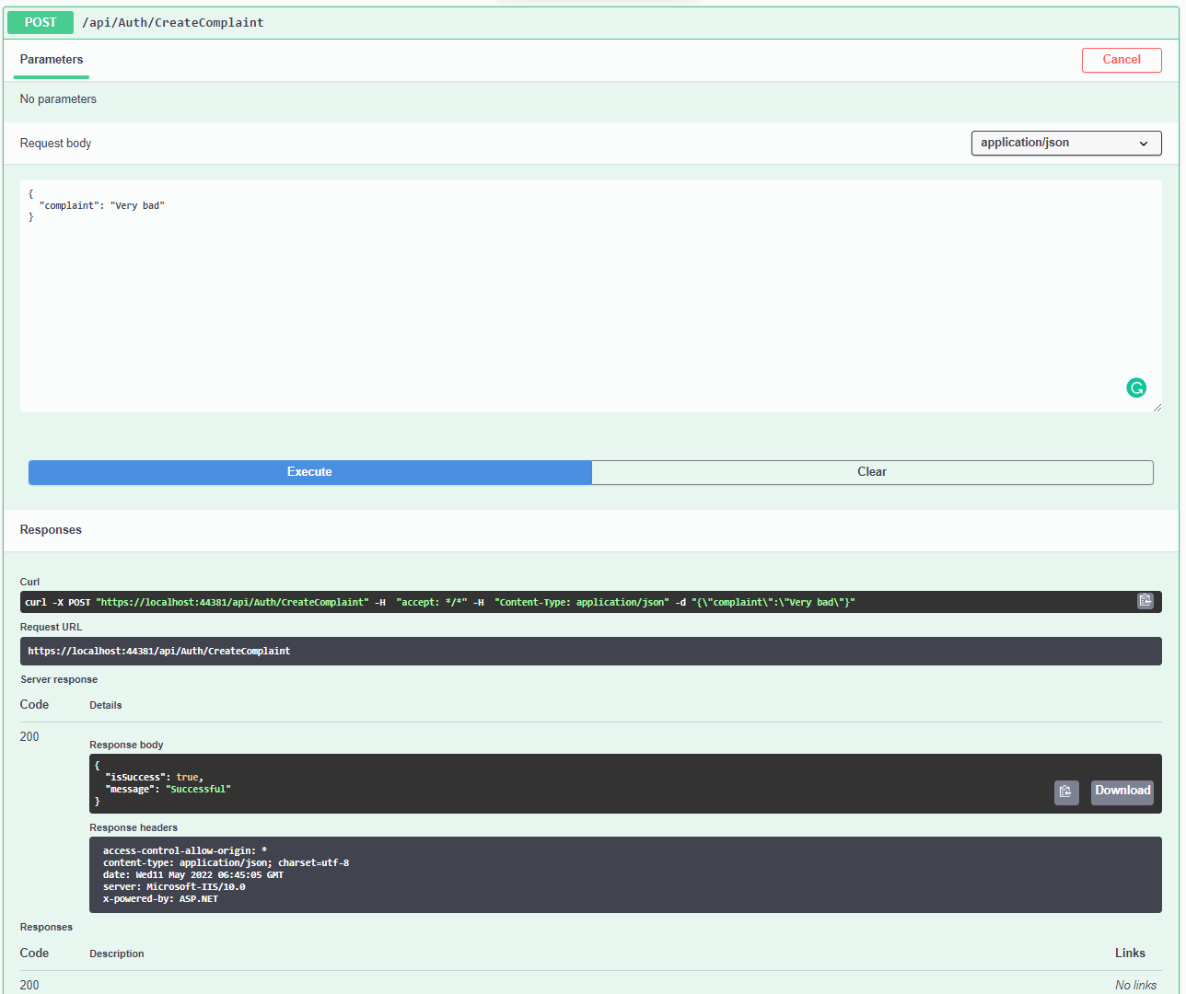

Figure 46 - Run-Time: Create a Complaint by Citizen with JSON result

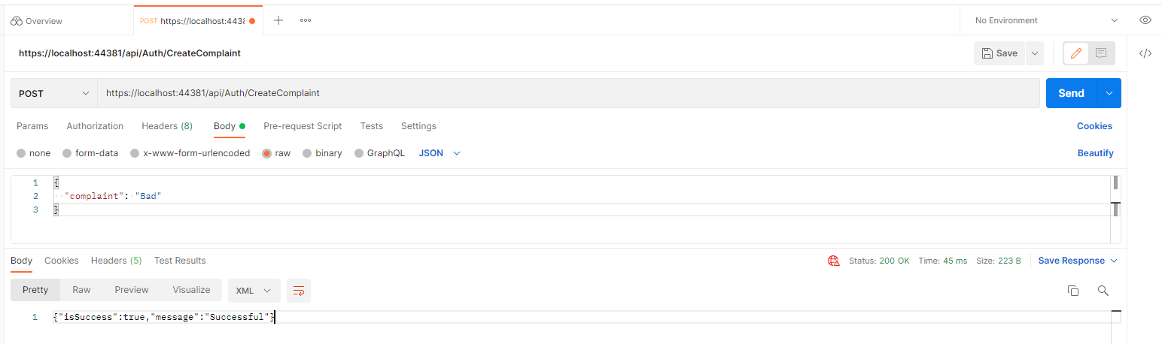

Figure 47 - Run-Time: Create a Complaint by Citizen with XML result

Get List of Complaints

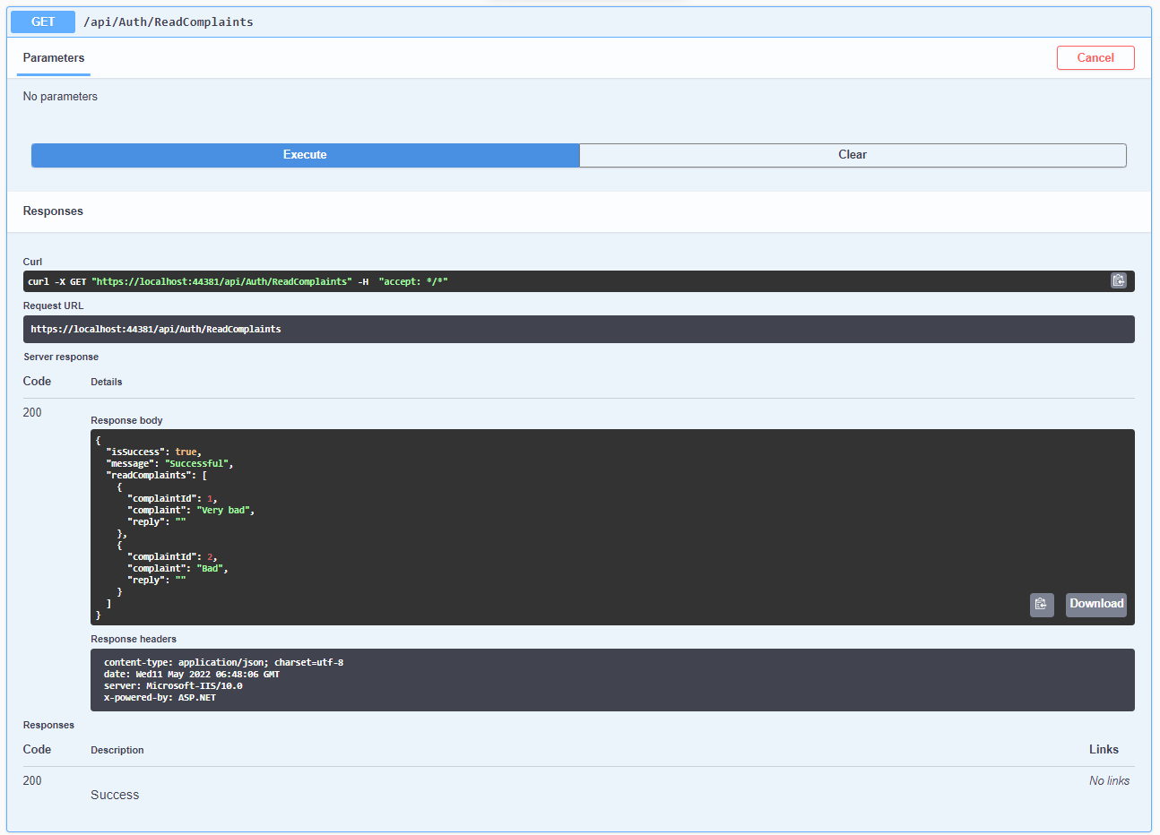

Figure 48 - Run-Time: Get List of Complaints with JSON result

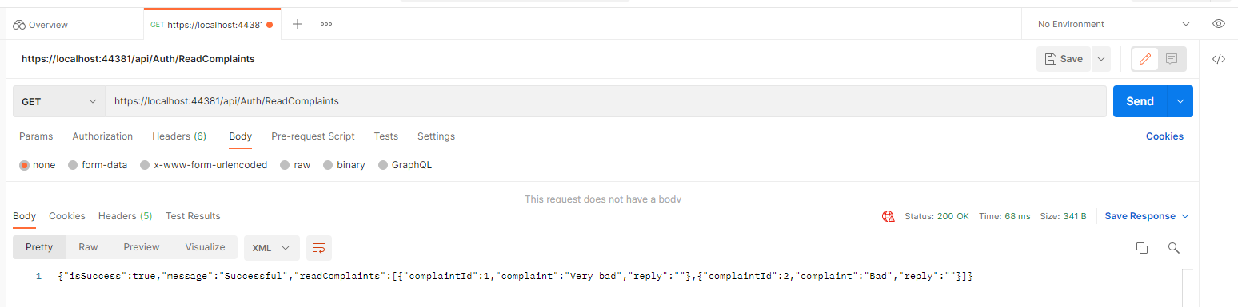

Figure 49 - Run-Time: Get List of Complaints with XML result

Reply to the Citizen's Complaint

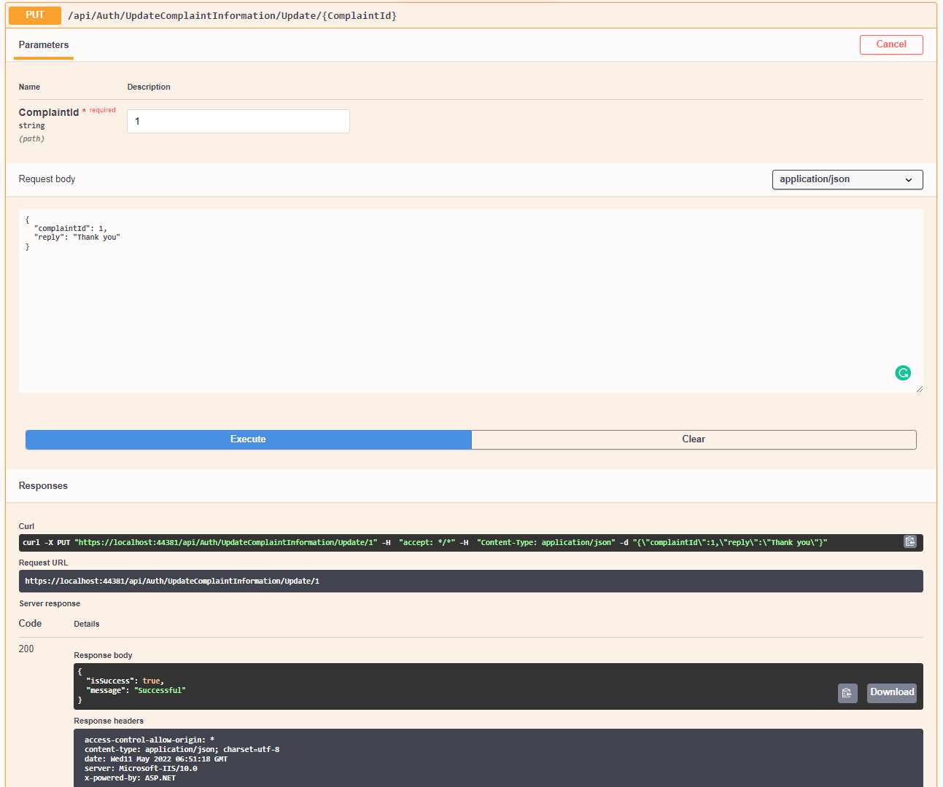

Figure 50 - Run-Time: Reply to the Citizen's Complaint with JSON result

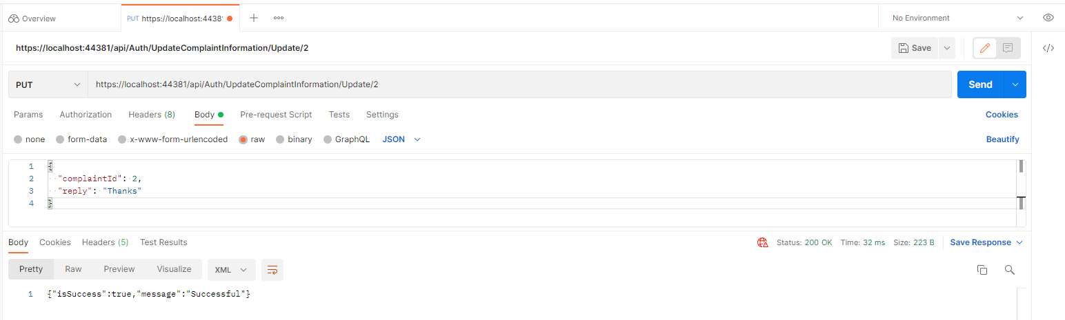

Figure 51 - Run-Time: Reply to the Citizen's Complaint with XML result

#### Mobile Application

Sign Up Forms => Citizen and Officer Sign In forms => Citizen and Officer

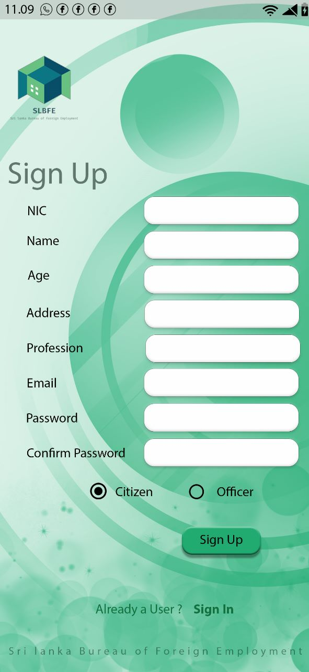 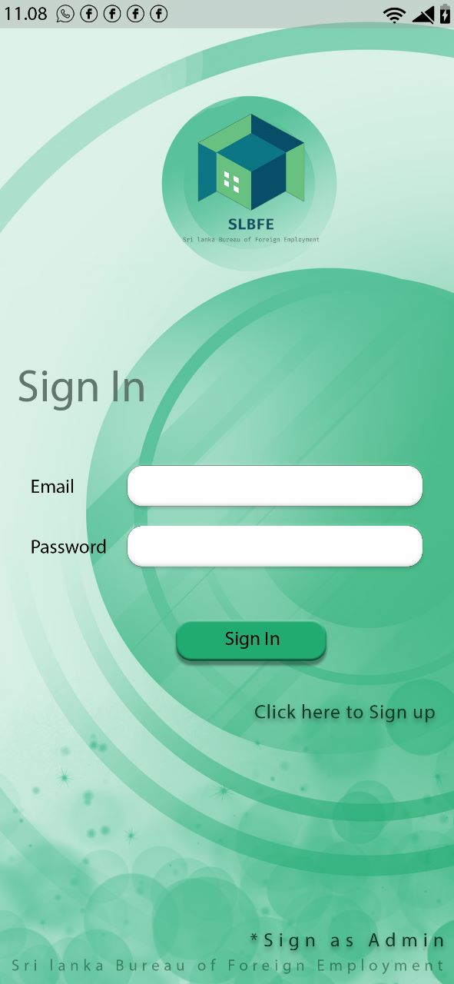

* When new user comes into the system he must be register to the system. They can choose either option from Citizen and Officer and signup with the system. They should fill all the fields (NIC, Name, Age, Address, Profession, Email, password and confirm password and check the radio button called. Then new user can press the sign-up button and able to be a new member of SLBFE company.
* After signing up with the system whether the user is a citizen, officer, or admin they will be redirected to their own signing pages where they must enter only the email and password. They must enter correct credentials to log in.

Sign Up Form => Citizen Dashboard / Home page => Citizen

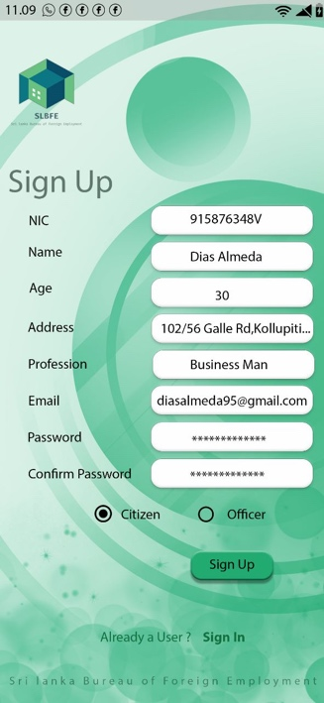 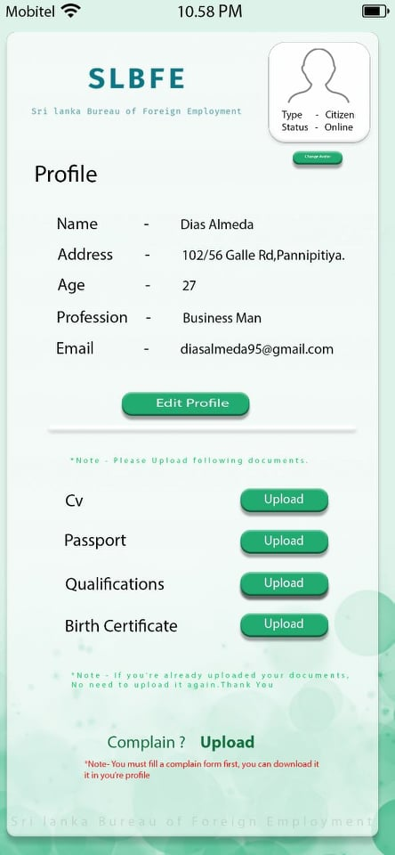

* When a citizen signup to the system their credentials will be sent to the database through an API and check whether there is an existing user with those credentials. If not, the user will be signed up with the system and then have to login with the previously entered details, which will call the APIs to check whether they have entered correct credentials. In the home page the citizen can edit their details and upload any documents they want through the application. They also can make a complaint by uploading a complaint. All these functions are sent to the database through APIs.

Home Page / Dashboard => Officer

Selecting by NIC Selecting by Qualification Selection of all records

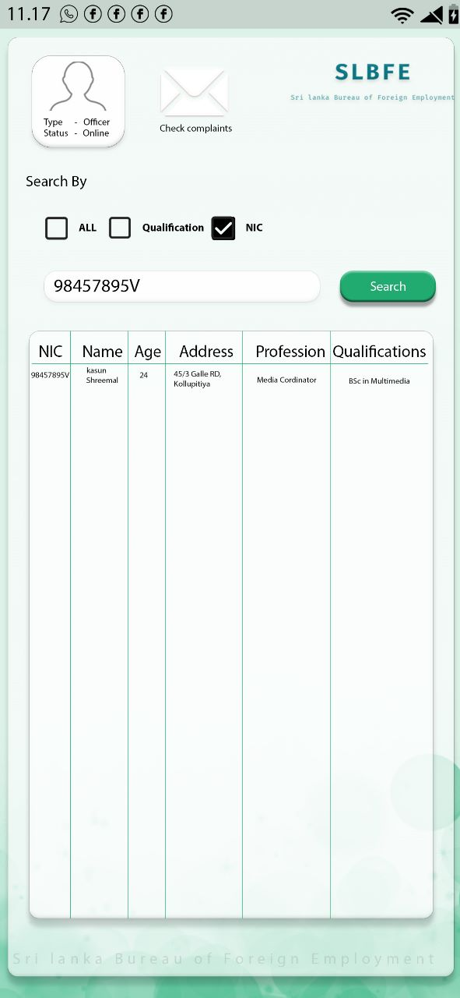 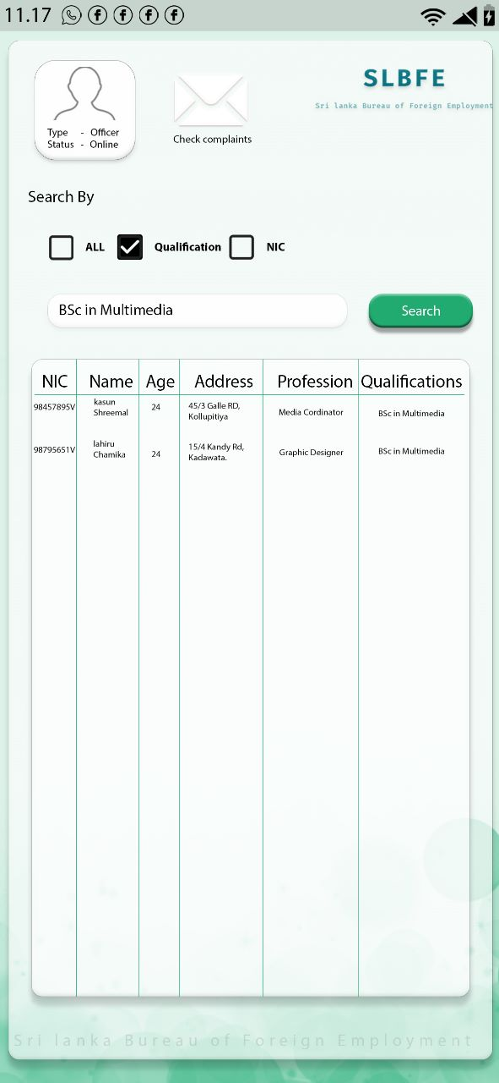 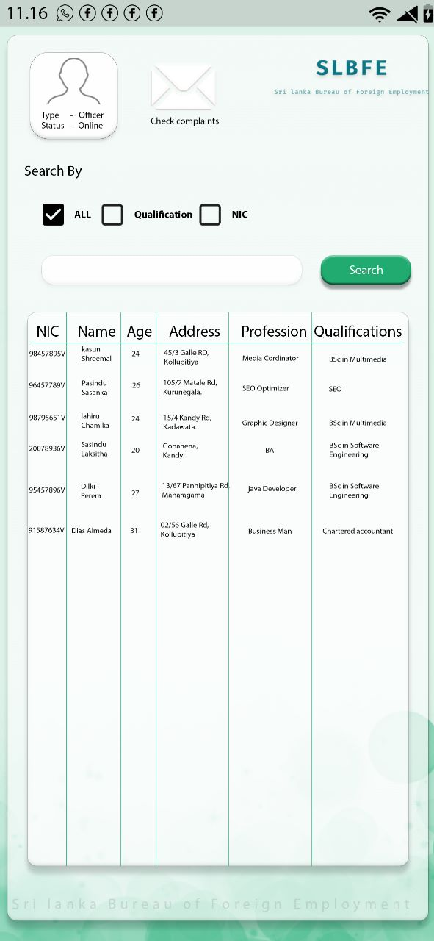

* By selecting Officer’s radio button in the signup form the signup details of the officer will be shown and when officer signup to the system their credentials will be sent to the database through an API and check whether there is an existing user with those credentials. If not, the officer will be signed up with the system and then have to login with the previously entered details, which will call the APIs to check whether they have entered correct credentials.
* In the above screenshots by selecting a query and searching them in a search bar panel the API will request to check whether the entered value is there in the body and return the response values with the entered search items. By ticking NIC and searching a NIC number if citizen details are there with the searched NIC number the results will be shown in the table. Like that by ticking the box the responses will be shown in the table.

Sign Up => Admin Home Page => Home Page / Dashboard

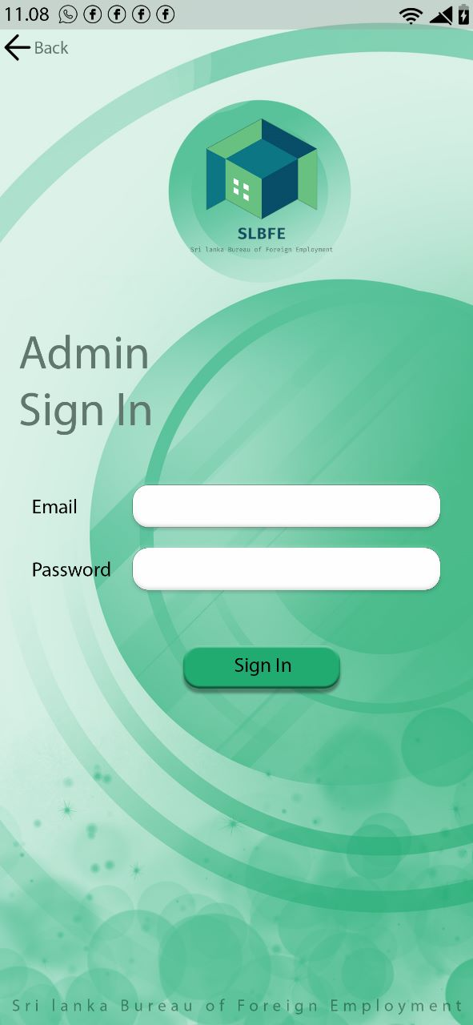 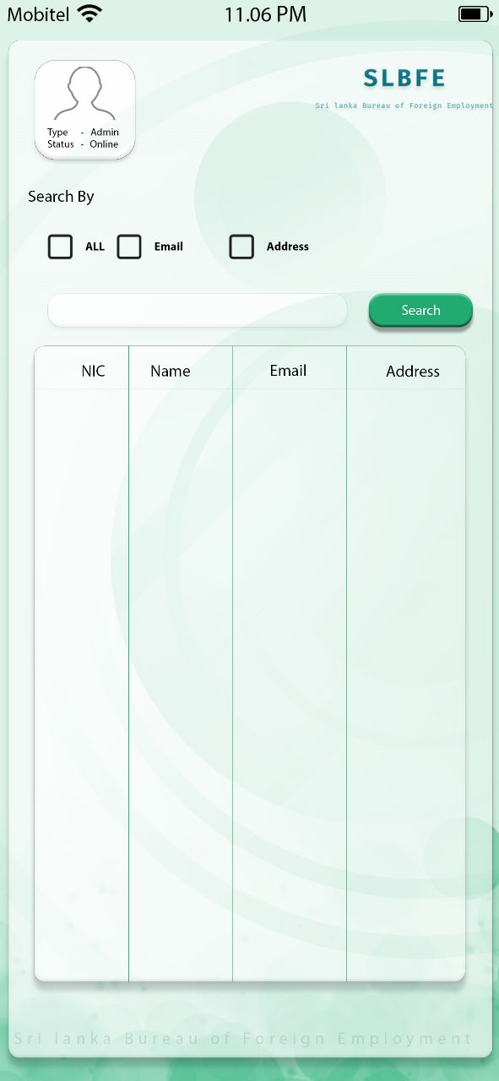

* The admin has its own email and password so a new admin cannot register with the system. When the admin enters its credentials, a request will be sent through API to check whether there is an admin with that credentials. So, if the credentials match, he will be redirected to the system. The above screenshots show the login and dashboard of the admin.

Selecting all records Selecting by Email and Address

 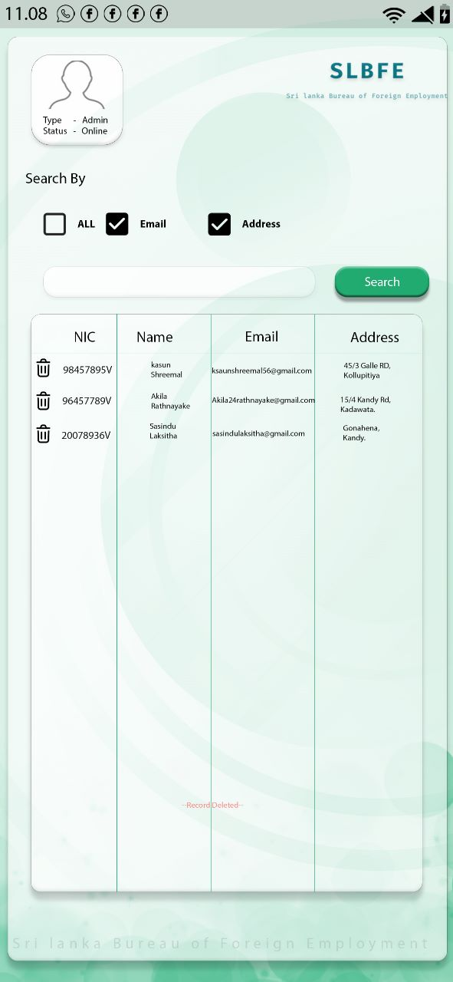

* This is the dashboard of the admin and in the above screenshots by selecting a query and searching them in a search bar panel the API will request to check whether the entered value is there in the body and return the response values with the entered search items. By selecting all, all the records in the body will be shown in the table by sending a request through API and the responses will be given according to the request. So, the admin can view the responses given by the APIs. Also, they can delete any account that they think of no longer in use.

## **Tools and Technologies**

* When developing the backend of this application we chose ASP .Net web API since this is the backend technology that we are most familiar with and given the limited time frame this let us develop the application faster and easier while resolving the bugs and errors much faster than if we used some other technology.
* The APIs related to the application are deployed and run-on Swagger. The APIs have been tested on Swagger before releasing to the public.

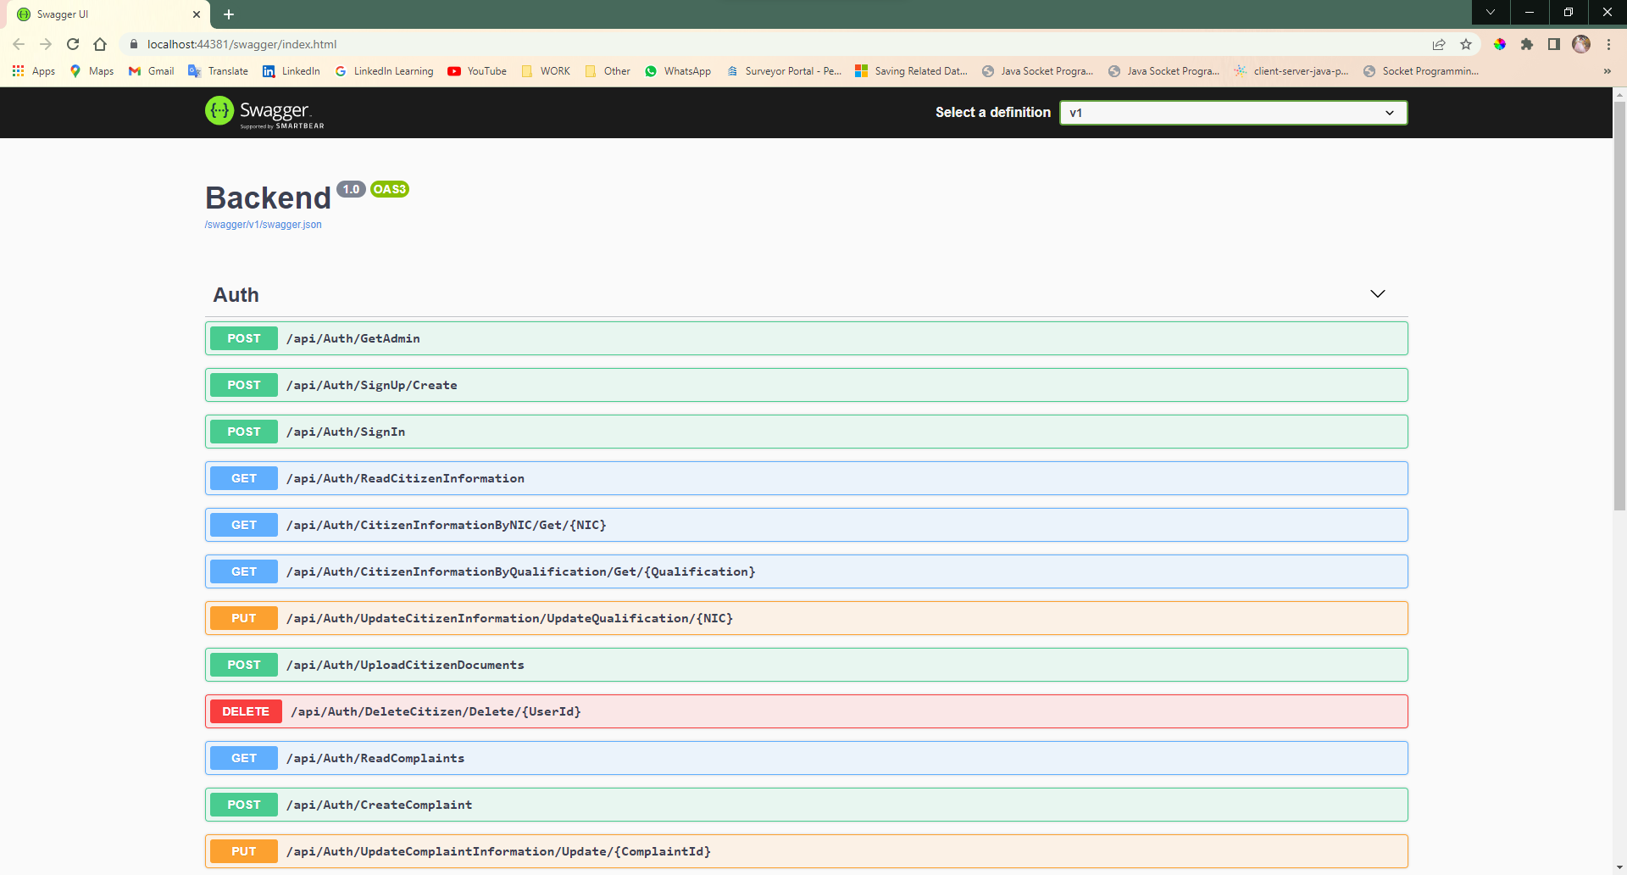

*Figure 52 - Swagger API Manager*

* The database that was utilized for this application is the MYSQL database.

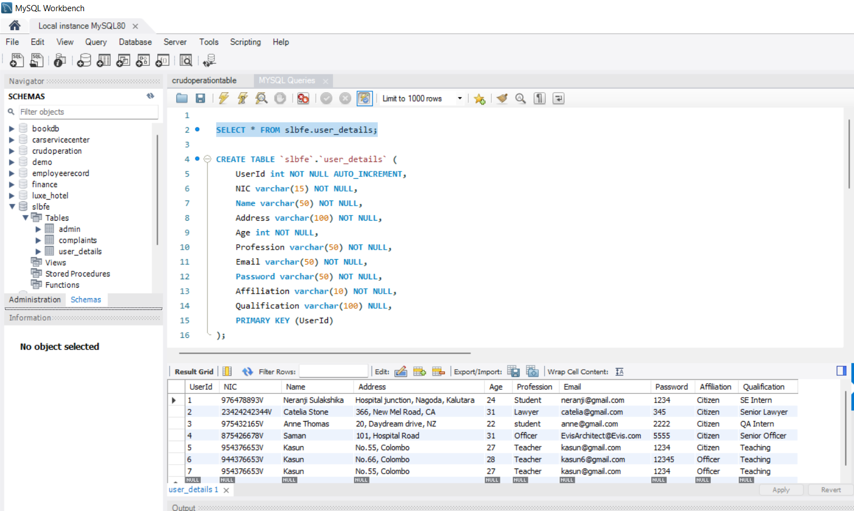

Figure 53 - Execute Screenshot of the user_details table result

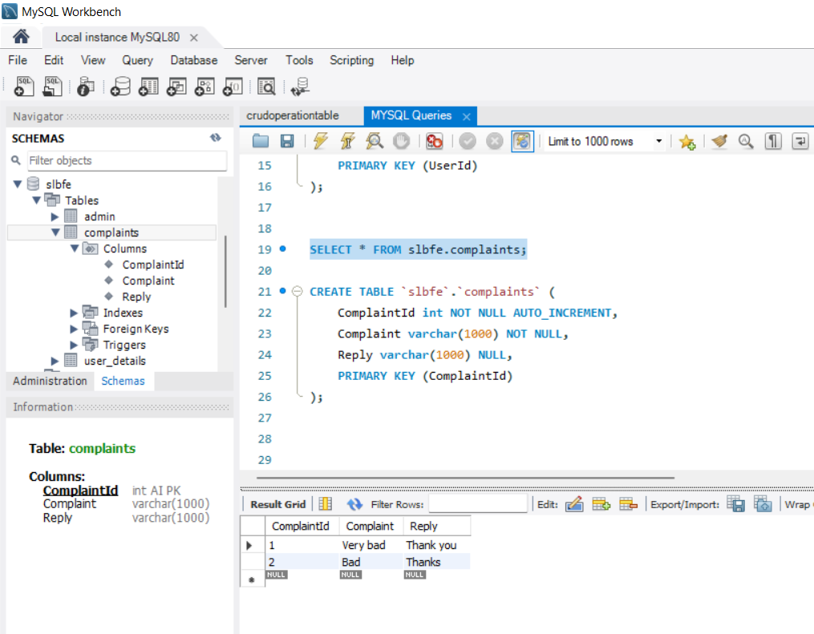

Figure 54 - Execute Screenshot of the complaints table result

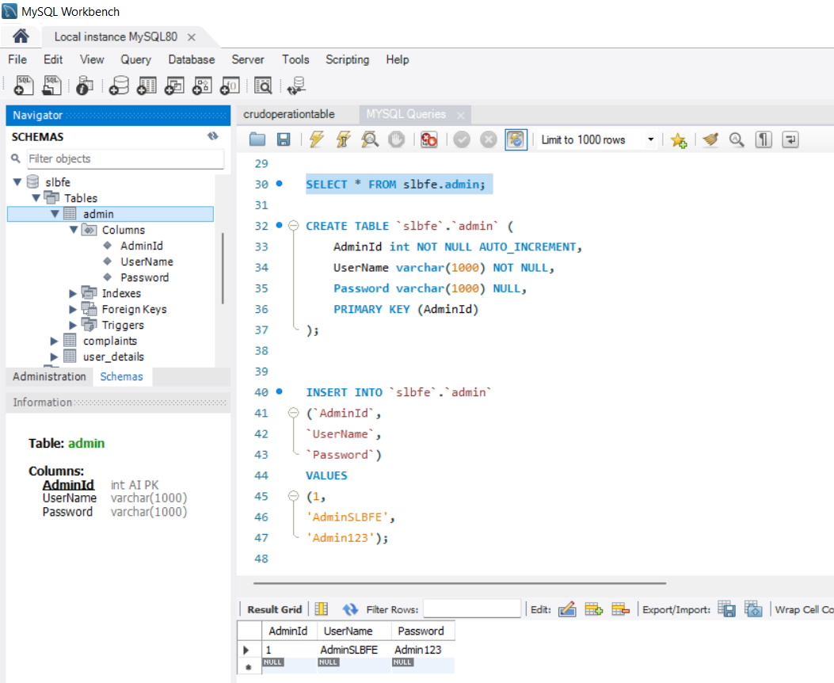

Figure 55 - Execute Screenshot of the admin table result

* Since this is an application developed to help find jobs by having both mobile and web applications, they can reach a high audience as anyone can access either via web or app. By using a mobile app, they can access to the app easily and the functions would run smoothly. Therefore, a mobile application was created to cater more of SLBFE customers.

### Platform - Web Platform

* A web application was created in order to access the system through the web for those who prefer to use this application in their computer.
* When developing the SLBFE web application we utilized ASP .NET in developing the backend, Swagger for managing the implemented APIs.
* For the frontend development of the web application, we utilized ReactJS since it is a versatile framework that enable us to develop responsive interfaces.

### Platform – Mobile Platform

* To build the SLBFE mobile application many technologies was used. This application is an android application which was developed in Android Studio IDE. The application was created with Java language and the backend was ASP.NET. And as for the communication of APIs Retrofit was used. Retrofit is a REST client designed for Java and Android which allows to upload and retrieve JSON. By using Retrofit it is easy to use APIs with the designed user interfaces.

## **Individual Contribution**

### 10707385 - V P N Sulakshika

I was responsible for implementing the complete backend of the application with all the API configurations. This consists of the ‘get admin’ which is capable of retrieving the admin profile when logging into the system, ‘create’ is capable of creating the citizen and officer profiles, ‘Sign-In is responsible for retrieving the citizen and officer profiles when logging into the system, ‘read citizen information’ is an API which enables the admin and officers to read the details of the citizens, ’Citizen Information by NIC’ capable of retrieving the details of particular citizens by providing the NIC number of that citizen, ‘Citizen Information by Qualification’ enables the officers to read the details of the citizens with regards to their qualifications. The officers are able to find candidates based on their qualifications with this API. ‘Update Qualification’ enables the citizens to update their qualifications after the creation of their profile. ‘Upload Citizen Documents’ enables the citizens to upload their documents to the systems, ‘Delete Citizen’ can be used by the admin to disable the accounts of the citizens, ‘Create Complaint’ enables the citizens to generate and submit complaints, ‘Read Complaints’ enables the officers and citizens to view the complaints posted by the citizens. ‘Update Complaint Information’ enables the offers to reply to the complaints posted by the citizens.

 *Figure 56 - The Full Backend API Part*

As for the frontend development, I was responsible for developing the citizen Sign-In page, officer Sign-In page, citizen signup page, and officer signup page for the roles of the citizen and the officers. I was also responsible for developing the Sign-In page for the admin, the list of citizens the admin could view, and the citizen deletes function for the admin. And also, these all fields are validated.



Figure 57- The Frontend Part (Citizen & Office: SignUp)



Figure 58 - The Frontend Part (Citizen & Office: SignIn)



Figure 59 - The Frontend Part (Admin SignIn)



Figure 60 - The Frontend Part (Admin Home Page with View & Delete Citizens’ Information)

### 10707241 - H S Kaushalya

I made the mobile application with my other two colleagues. There I made the registration and homepage of the citizen along with its backend. I used retrofit 2 service for the API data communication all user input data are handle by the APIs and I use post method for the user registration, from that method all the user’s credentials are store to the data base by post API and I used get API for the signing process .In that method When user input his user name and password first it get all the usernames in the table and check the username is available or not in the database if it is available then it get the password which belongs to that username and then check whether the user input password is same to the password which on database if those are correct then user can login to the system successfully

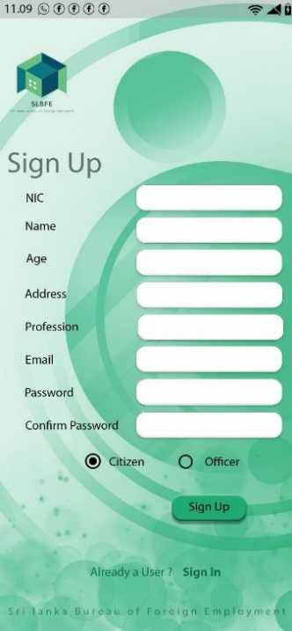  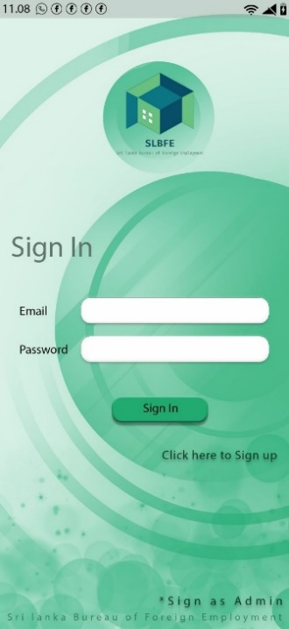

### 10707417 – H J K I Wijerama

I created Admin Sign-In page. I used GET API for the sign in process of Admin. Admin can sign up by entering their username and email. Then that data check with the database and if they are available admin can sign in successfully. If the data in the database doesn’t match with the entered data, admin is not able to log into the system.

I was also responsible for developing the home page for the admin. It includes the list of citizens that admin can view by filtering their contacts details like email and address. For that function I used GET API for get all the requested data filtering by email and the address from the database and display them in the mobile application. And also, admin have the delete function to delete any citizen. For the delete function I used DELETE API. All the data should retrieve from database.

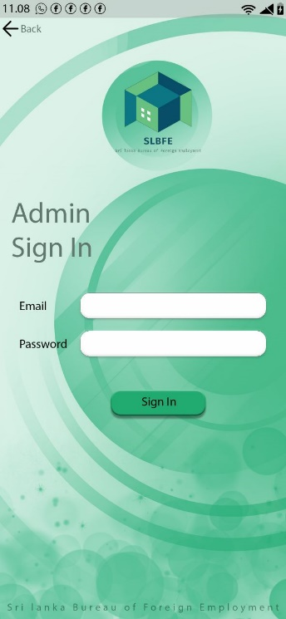 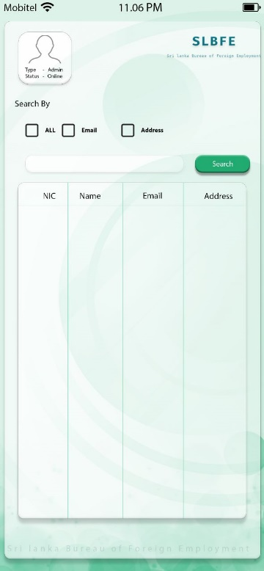 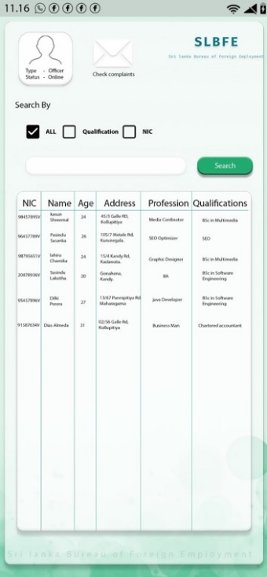 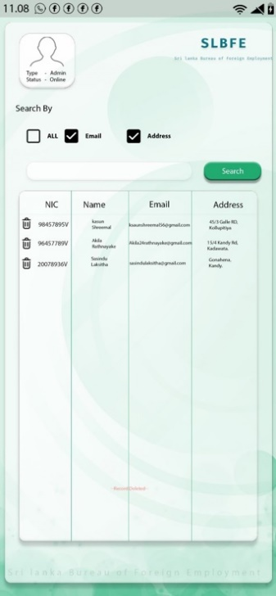

### 10707129 – K L D Anupama

As for the frontend development of mobile application, I was responsible for developing the Officer Sign-In page, officer Sign-up page. I was also responsible for developing the home page for the officer, the list of citizens filtering by NIC of citizens and the Qualifications of citizens. To check the data of citizens by NIC and the qualifications, GET API is used. And also, officers can check complaints. I created the complaint reply interface to view reply to complaints by GET API. All the data should retrieve from database.

All the officer credentials are store to the database by POST API and I used to retrofit 2 service for the API communication. All officers’ inputs and outputs are handled by APIs. From POST method all officers’ inputs store into the database and I used GET API for sign in process. From that method, when officer enter their credentials, then check from the database availability and the accuracy of the data. If the password and the username of the given officer is available officer can successfully log into the system.

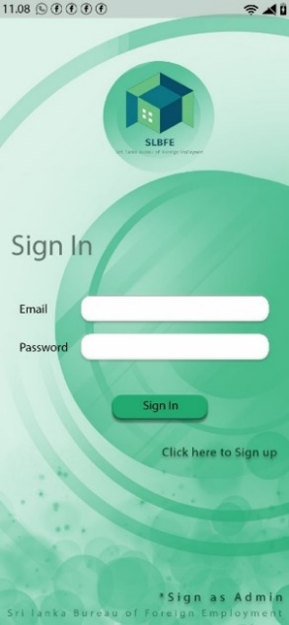 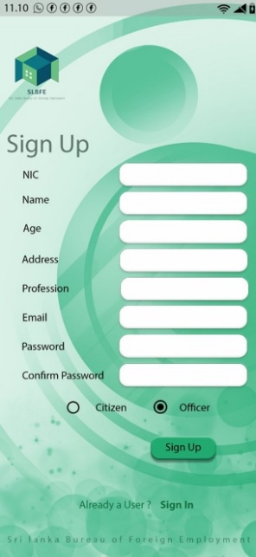 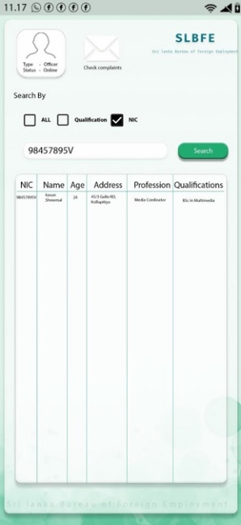 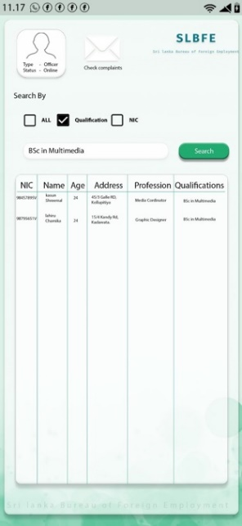 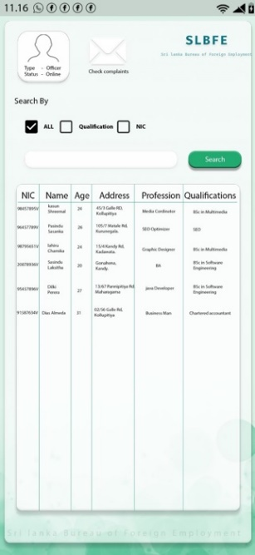 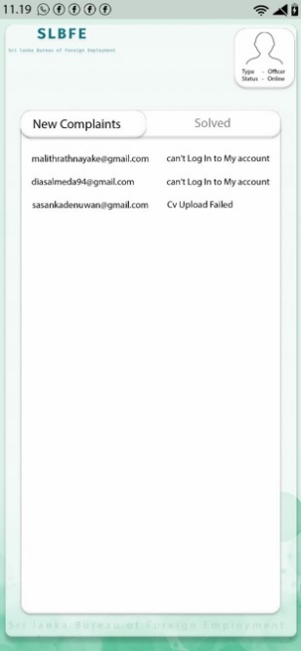

### 10707372 - P D S Sigera

In this coursework my contribution goes out, as to creating the citizens homepage frontend part. In the registration form the citizens have to fill out their personal information such as NIC, Name, Address, Age, Profession, Current Location, Email, Password, Affiliation. There are two functions for this citizen frontend part, they are POST method and PUT method. In the POST method is to update the data on the server and the PUT method is to add new data on the server. In the POST method the citizen can upload their birth certificates, their CVs and their passport copies. In the PUT method the citizen can update their current location (longitude and latitude) and also make a complaint if necessary. I have used React JS in implementing the code of the frontend and for the database I have used MYSQL Workbench in implementing the database.

Screen shots of the code Citizen Home Page

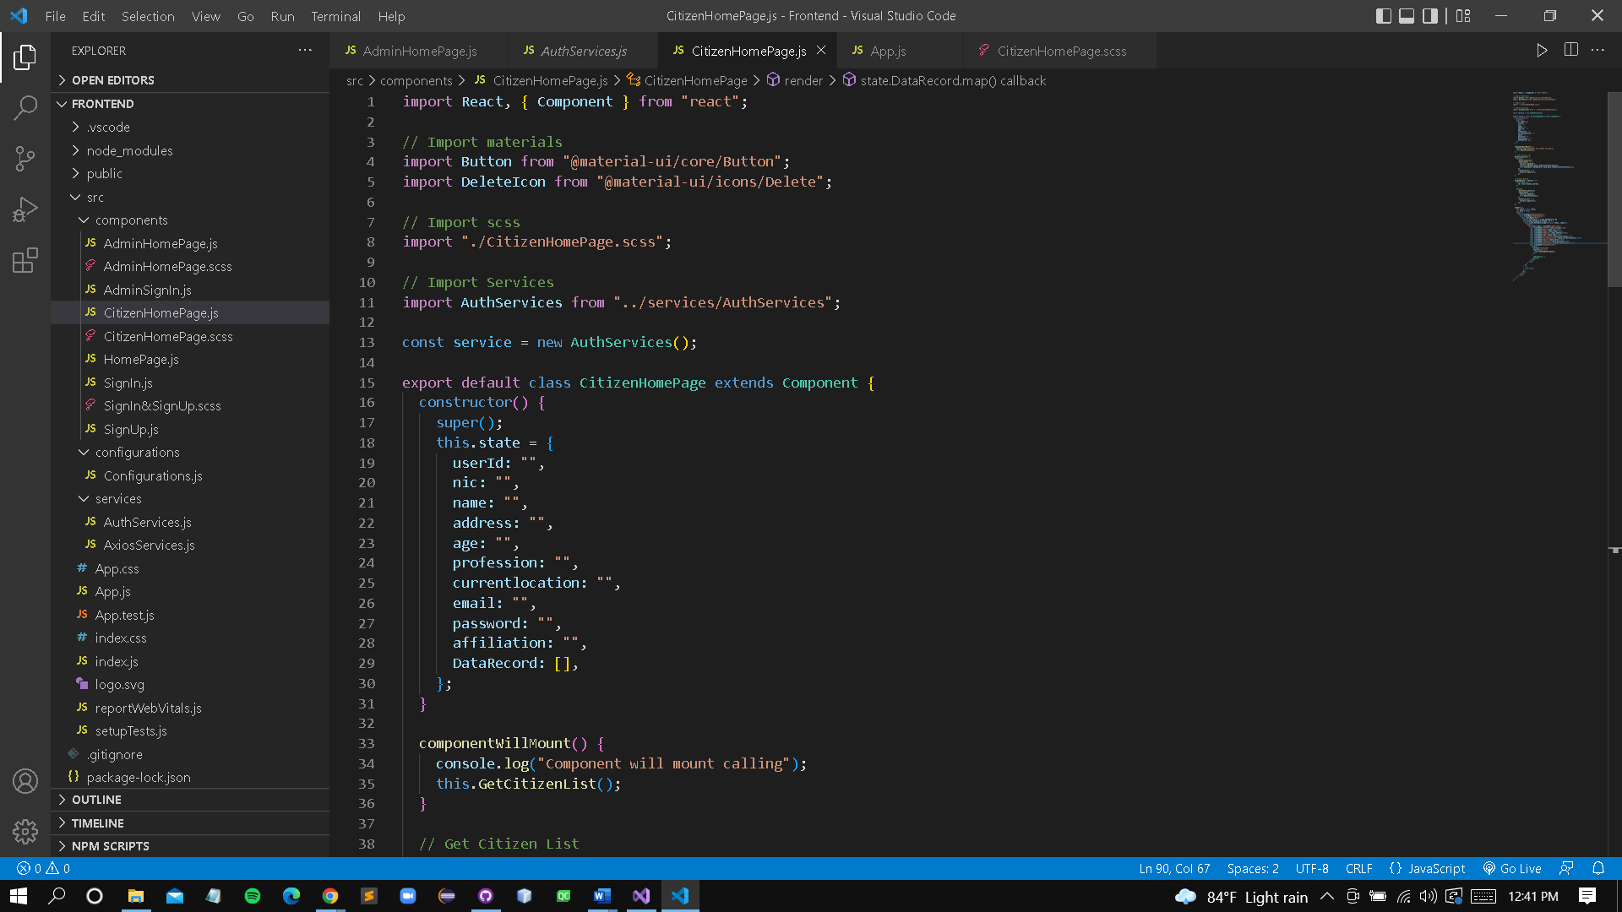

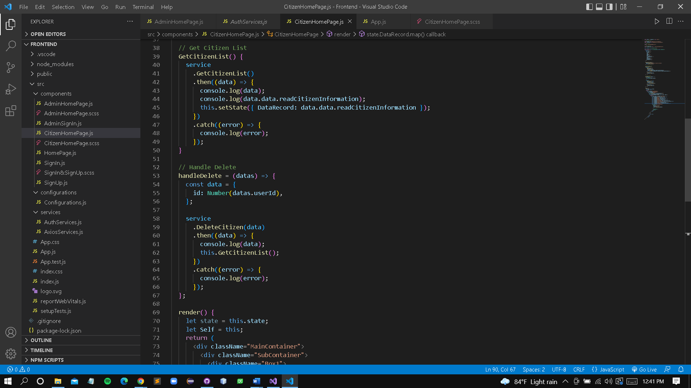

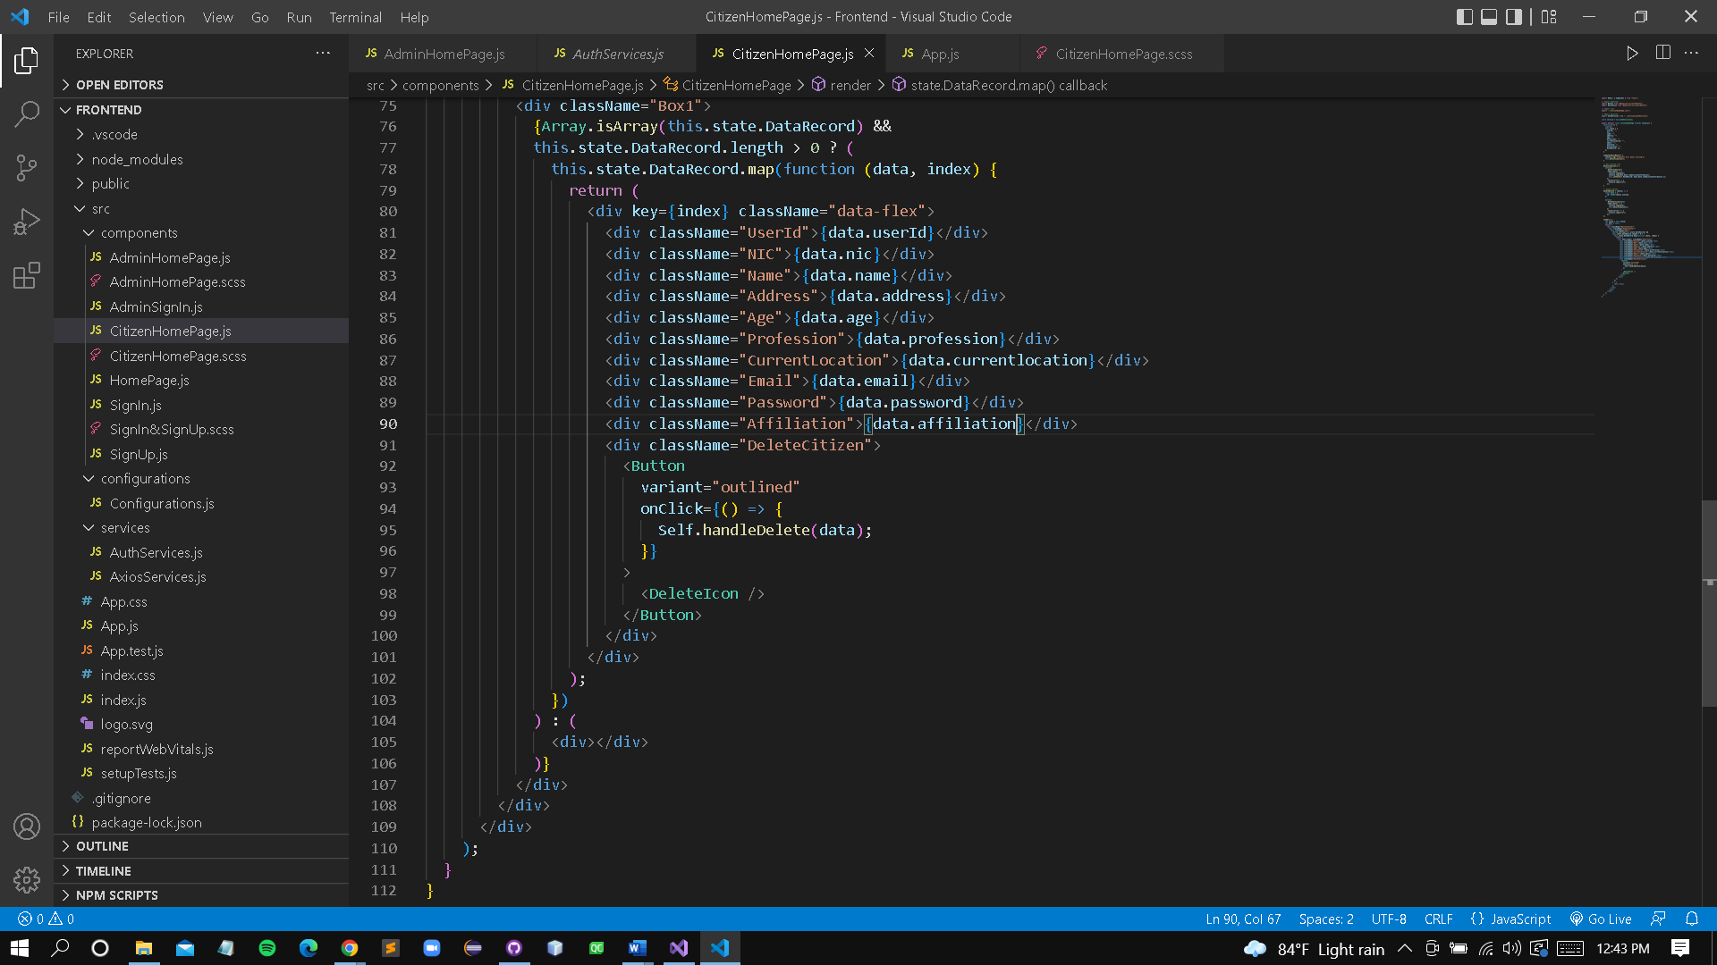

### 10707291 – S S N S Nevins

## Certificates

### 10707385 - V P N Sulakshika

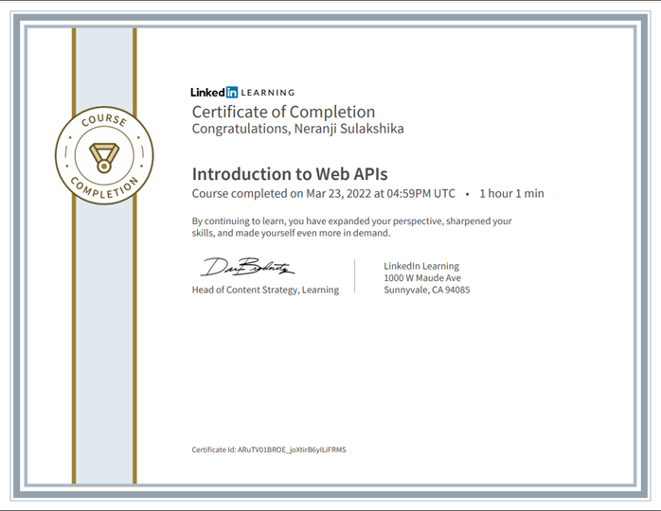

Figure 62 - LinkedIn certificate: 10707385

### 10707241 - H S Kaushalya

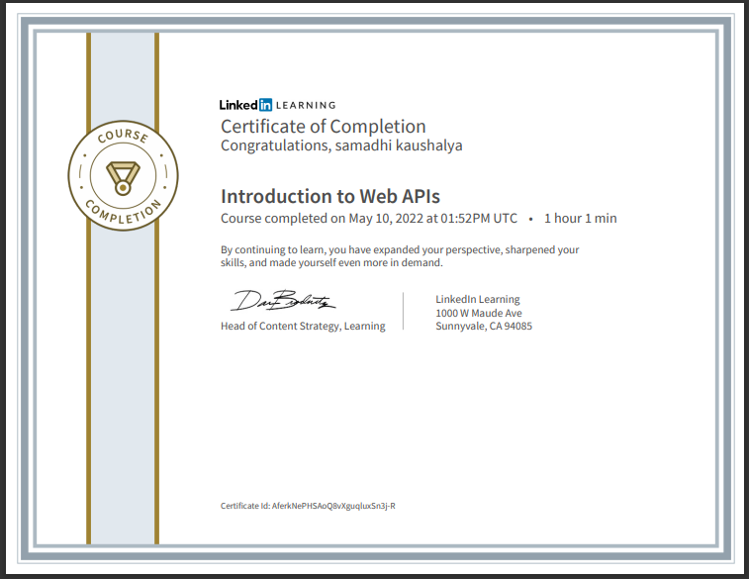

Figure 63 - LinkedIn certificate: 10707241

### 10707417 – H J K I Wijerama

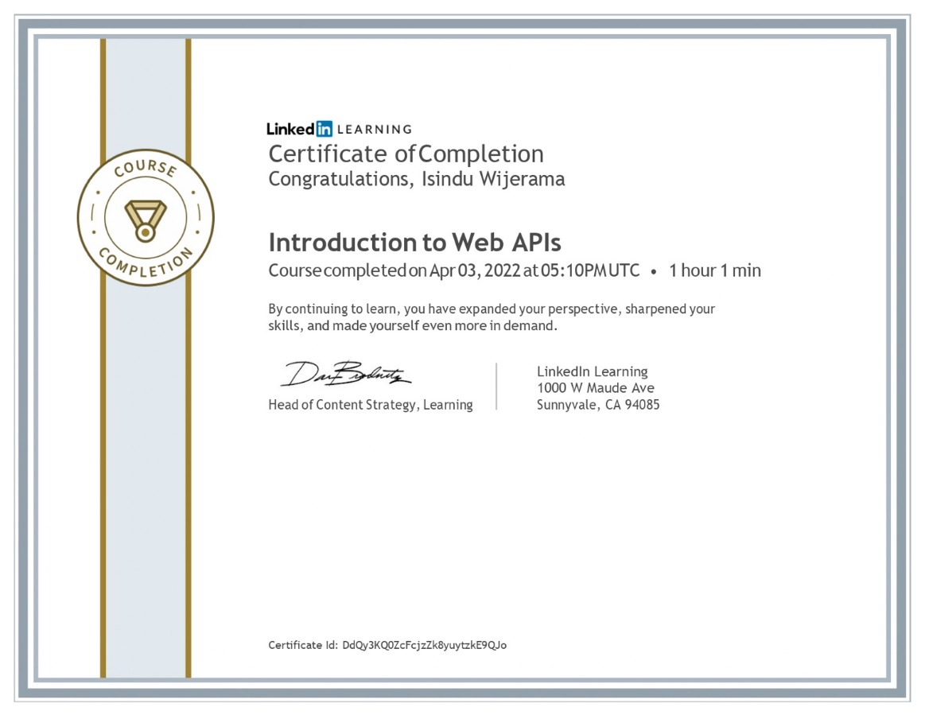

Figure 64 - LinkedIn certificate: 10707417

### 10707129 – K L D Anupama

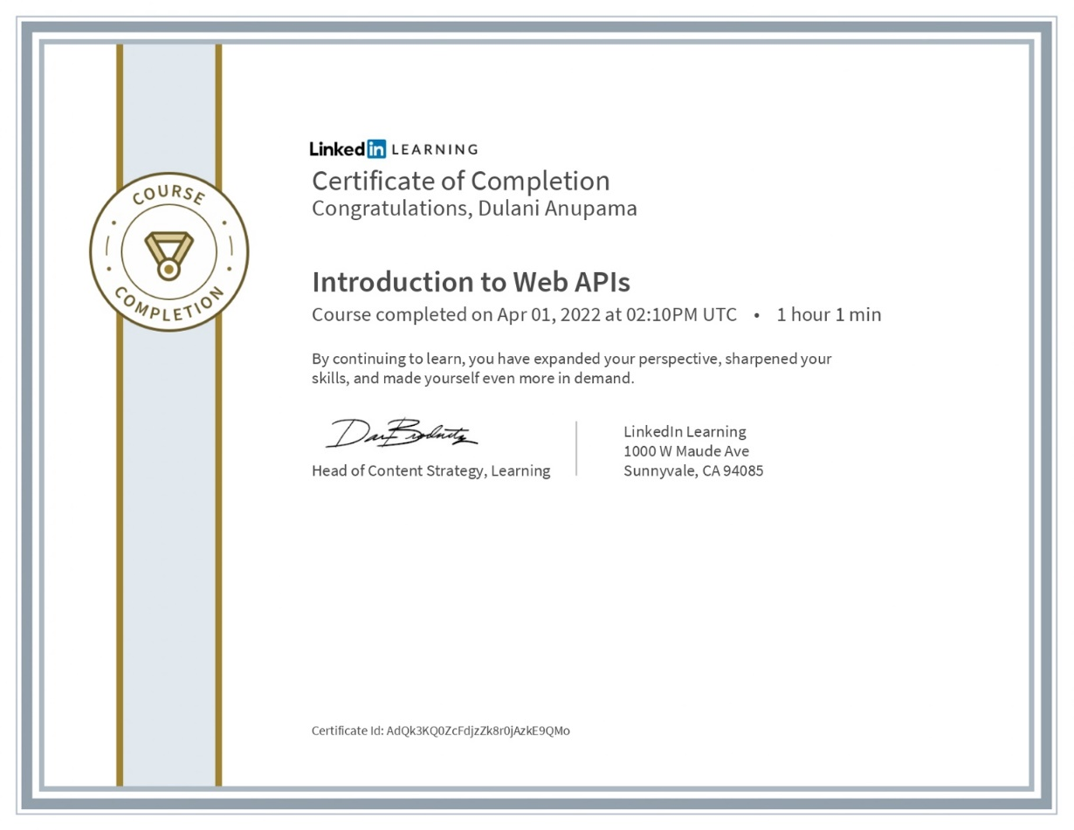

Figure 65 - LinkedIn certificate: 10707129

### 10707372 - P D S Sigera



Figure 66 - LinkedIn certificate: 10707372

### 10707291 – S S N S Nevins

## Risks and Outcomes

## Summary

## Conclusion

## References